2021 Virtual Conference Social Media Information
Thank you for sponsoring or exhibiting at GFOA’s upcoming Virtual Conference. Included below is helpful information regarding GFOA’s social media accounts, example posts, and visuals when referencing the conference on your social media platforms. If you have any questions regarding social media, please reach out to tmartin@gfoa.org.

GFOA’s Social Media Platforms
If you haven’t already done so, we encourage you to follow GFOA on Facebook, Twitter, LinkedIn, and Instagram. Below are links to our accounts and follower numbers on each account as of May 3.

- LinkedIn: https://www.linkedin.com/company/59136 (21,195 Followers)
- Facebook: https://www.facebook.com/GFOAofUSandCanada (7,787 Followers)
- Twitter: https://twitter.com/GFOA (4,183 Followers)
- Instagram: https://instagram.com/GFOA_ (177 Followers)

As we post about conference sponsors and exhibitors on social, this will get you in front of not only those that are attending the virtual conference, but all of our social media followers.

Official Conference Hashtag
This year’s official conference hashtag will be #GFOAVirtual2021. Please use this hashtag when referencing GFOA’s Virtual Conference on social media. You’re also encourage to tag our social media accounts when posting.

Virtual Social Wall
New this year, GFOA will be adding a virtual social media wall for conference attendees to view as they spend time on the conference website. This will be a great opportunity for you to push your message out to attendees. Posts that include #GFOAVirtual2021 will be displayed on the wall.

Example Social Media Posts
Below are example posts for conference sponsors and exhibitors to use when referencing GFOA’s Virtual Conference. Please feel free to adjust the language below for your audience.

- Sponsors
“(Sponsor Name) is excited to sponsor GFOA’s Virtual Conference, July 12-23. Register to hear from leading practitioners, recognized #publicfinance industry experts, researchers, and more on how to prioritize the current needs of you community for any future challenges.” Learn more: https://gfoa.org/conference #GFOAVirtual2021

- Exhibitors
(Exhibitor Name) is excited to exhibit at GFOA’s Virtual Conference, July 12-23. Along with the outstanding #publicfinance sessions scheduled, attendees will have an opportunity to interact with us and win prizes in the Virtual Exhibit Hall. Register for the conference now at https://gfoa.org/conference. #GFOAVirtual2021

The above are examples for announcing your company’s involvement with the conference. To build excitement and awareness, please feel free to post as frequently as you like leading up to and during the event. Exhibitors are encouraged to post about opportunities in the Virtual Exhibit Hall throughout the event. For exhibitors scheduling prize giveaways during the conference, please email those schedules to tmartin@gfoa.org.

Example Social Media Images
(Right click on photo and click “Save as Picture”)

- For Facebook, Twitter, or LinkedIn
  - 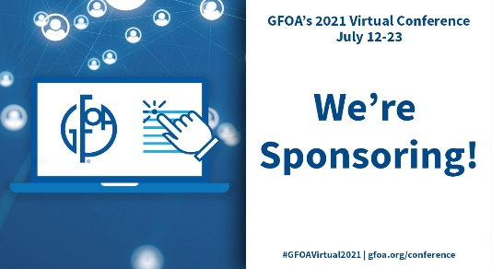

- For Instagram

