Standard ERP Governance Model

Below is a typical project governance model. This provides essential roles for the steering committee, project manager, and project team. If necessary, governments may want to consider an additional administrative support role to ease the burden on the project manager.

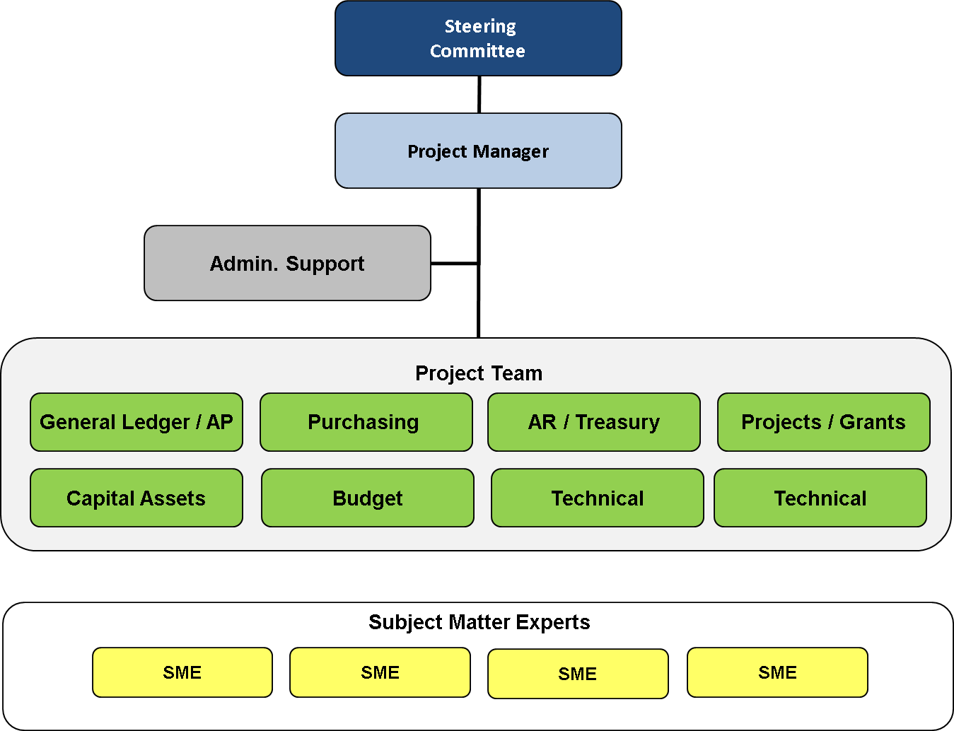

Standard ERP Roles
The following table identifies common responsibilities for each role during both the ERP preparation (readiness) phase and the actual software implementation.

Role | Responsibilities
Steering Committee | - Preparation  - Identify project vision and goals.  - Identifies project team members.  - Communicate project throughout the organization.  - Provides periodic updates to the County Board.  - Approve key decisions on project scope, schedule, and budget.  - Receive regular updates on the status of the project.  - Implementation  - Provides general oversight of the project.  - Make key policy decisions on project  - Review and approve/revise recommendations from project team and project manager  - Acts as change agents for the entire County.  - Resolves conflicts over policy or objectives within their control/authority.  - Provides advisory and consultative direction for project when requested by project manager.  - Approves any changes to project scope, schedule, and budget.  - Assures staff and resources for the project.  - Resolve project issues that are escalated to the steering committee.  - Provides periodic updates to the County Board.
Project Manager (PMO) | - Preparation  - Responsible for implementing the project plan.  - Coordinates the day to day activities of the project teams and timelines.  - Manage scope, schedule, and budget  - Responsible for the detailed planning of a project  - Manage and organize project documentation  - Communicates project status to the Steering Committee.  - Determines the priority of work assignments and changes.  - Oversee related policies and procedures development developed as part of this project.  - Recommend policy and procedure changes to Steering Committee and County Board.  - Implementation  - Manage scope, schedule, and budget  - Primary point of contact with vendor  - Oversees implementation consultants  - Coordinates the day to day activities of County resources  - Reviews and accepts deliverables  - Communicates project status to the Steering Committee  - Oversee related policies and procedures development developed as part of this project.  - Recommend policy and procedure changes to Steering Committee and County Board.  - Manages County staff assigned to ERP project
Project Team / PIT Crews | - Preparation  - Identifies department mapping and requirements participants  - Participates in mapping and requirements development meetings  - Reviews and validates functional and technical requirements  - Conducts research of functional issues as required.  - Responsible for sign-off of functional area requirements accuracy and completeness as to the opinion specified by the subject matter experts.  - Make policies and procedures recommendations to the steering committee.  - Provides feedback on project deliverables.  - Assist in development of policies and procedures for enhanced business processes.  - Implementation  - Participates in day to day activities of the project.  - Makes many decisions on system and process configurations.  - Works with vendor consultants on day to day basis  - Serves as liaison to department subject matter experts  - Participates in all system training and becomes knowledgeable on all system features within area  - Participates in design sessions and is empowered to make design decision.  - Participates in system testing and approves completion of testing for their responsible function.  - Participates in system configuration and reviews and approves data that is loaded into new system.  - Completes system and business process documentation  - Document and share any issues where the team cannot make decisions to the project director.  - Leads data conversion planning an d testing.  - Assists with training and change management.  - Make policies and procedures recommendations to Director and PMOs.  - Assist in development of policies and procedures for enhanced business processes.
Subject Matter Experts (SME) | - Preparation  - Provides direction in their defined area of expertise as needed by the Lead Team  - Implementation  - Participate in design, configuration, testing, documentation, and other activities during implementation.

Project Participation

Position | Role / Resource | Expected Participation / Readiness (hours/week) | Expected Participation / Implementation  (hours/week)
Steering Committee | Small Group (5-7 people) responsible for the project | - As needed  - 2-3 | - As needed  - 2-3
Project Manager | Single Resource | - 15-20 | - 30-40
Project Team / PIT Crew | Accounting | - 15-20 | - 25-40
 | Projects / Grants | - 15-20 | - 20-30
 | Budget | - 15-20 | - 15-30
 | Procure / Payables | - 15-20 | - 20-40
 | Treasury | - 5-10 | - 10-20
 | Asset Management | - 5-15 | - 20-40
 | Human Resources | - 15-20 | - 20-40
 | Payroll | - 15-20 | - 20-40
 | Licensing / Tax Collection | - 15-20 | - 20-40
Technical Team | Technical Leads | - 15-20
Subject Matter Experts | Department Representatives | - As needed  - Limited | - As needed  - 5 to 10 hours per week

