Introduction
Overview | Once your district is ready to implement the instructional priorities and resource allocation plans developed through Smarter School Spending it is important to communicate those decisions. It is important to convey this information in a way that is accessible to the public and connects the financial decisions to student outcomes. Developing a strategic financial plan will provide your district with an important tool for communication.
What is the challenge you are trying to solve? | Effective communication of decisions around instructional priorities and cost savings over the next 3-5 years.
What will you get out of this activity? | A tool that you can use to communicate the district’s priorities and financial plans over the next 3-5 years
When should we do this activity? | A strategic financial plan should be created once you have identified your instructional priorities and cost savings opportunities and made decisions about tradeoffs.
How long will it take to complete? | The technical work of compiling a strategic financial plan should take about one solid week, assuming that the other steps in the Smarter School Spending process were executed well. The challenge comes in gaining commitment to the plan. If you have followed an inclusive and fair planning process and kept stakeholders apprised throughout, then gaining commitment will be easier. If not, you may need to add significant time for communicating the plan and getting people on board.
Who should be involved? | Key financial and instructional staff should work to draft the plan. District leadership should be involved in reviewing and finalizing the plan before it is presented to the Board or public.
Is technical assistance support necessary? | No
Tips & Tricks | - See Strategic Financial Plans that were put together by the Alliance districts which can be found in the “Resources” section of the SSS site.  - The strategic financial plan can also be created as a PowerPoint presentation to help communicate to stakeholders

What is a "strategic financial plan"?
A strategic financial plan is a document that presents the district's strategic financial recommendations for the next three to five years in a format that will be easy to understand and that connects financial decisions to student achievement goals. This plan takes the work your district has done in identifying, analyzing, and estimating an amount for each investment and savings options and combines it into a document used by decision makers to assess your district’s proposals. This is a central document to be used in engaging stakeholders.

How to Use the Strategic financial plan Template:
This template for a strategic financial plan is a starting point. It outlines the key sections of an effective document:
- Introduction: What a strategic financial plan is and why it is important for your district.
- Background: Details of your district’s financial and student outcomes history.
- The Smarter School Spending Process: Outline of the process to create the strategic financial plan.
- Instructional Priorities: Your district’s proposed investments in for student achievement.
- Pay for Priorities: How your district proposes to pay for the instructional priorities.
- Tracking Progress: Plan for how your district will continue the efforts of the strategic finance process and track the progress of the proposed initiatives.
Within each section, the template provides an overview of what to include, key questions or topics to address, sample content to use, template charts to fill in, and additional tips to support the writing process.

Strategic Financial Plan
[YYYY]—[YYYY]

Submitted by the
[District Leadership Team]
[Date]

[District Logo]

LETTER TO THE COMMUNITY | Letter from the superintendent addressing the chair of the school board, members of the school board, and citizens of the community
Include in the letter brief overviews of the components in the plan, including but not limited to:
- Announcement of the submission of the strategic financial plan
- The purpose of a strategic financial plan
- Background on the district and the factors leading to the necessity of a strategic financial plan process
- List of priority investments, with associated costs
- List of realignment strategies to fund instructional priorities
- Plan for sustaining these efforts in the future
- Acknowledgement of the individuals and groups who supported the process

Follow the letter with a list of all groups involved in the process and the associated individuals and their titles. Include a note detailing how stakeholder input was solicited as part of the process.

Table of Contents
LETTER TO THE COMMUNITY 4
INTRODUCTION 6
BACKGROUND 8
THE STRATEGIC FINANCE PROCESS 10
INSTRUCTIONAL PRIORITIES 11
PAY FOR PRIORITIES 13
TRACKING PROGRESS 16
APPENDIX 18

INTRODUCTION | Explain what a strategic financial plan is and why it is a new and important approach for the district.
Address the following key questions:
- What are the objectives of this process?
  - Sample Text: This three-year strategic financial plan outlines the district's financial strategy over a three-year period. Its objectives are to:
- Identify the district's instructional priorities
- Estimate the costs of those priorities
- Describe the actions needed to save or realign money to fund those priorities

- What is a strategic financial plan?
(Below are some sample terms and phrases to use)
 | What It Is NOT: | What It IS:
Timeframe | NOT an annual budget | A multi-year plan (state the time horizon of your plan, which should be at least three years) that provides a financial blueprint for your district. It articulates the strategic investments your district aspires to make and identifies sources of funds to make these investments possible
Link to strategic priorities | NOT based on historical revenue/expenditure trajectories without links to strategic priorities | Translates your district’s instructional priorities into investment needs and estimates the full incremental cost of implementing these priorities over time, above and beyond current funding in these areas
Program effectiveness and student impact and outcomes | NOT disconnected from program/initiative effectiveness and return on investment | The effectiveness of various programs or initiatives undertaken as part of implementing your district’s instructional priorities is a central input to the decision-making process
Responsiveness to Changing Circumstances | NOT static | Will evolve each year. District leadership will update the plan on a rolling basis, as more information becomes available (e.g., as revenue estimates and student enrollment projections become more certain, and as program/initiative effectiveness data becomes available)
Stakeholder Engagement | NOT created based on input from a small group of staff | Involves input and contributions from a broad set of stakeholders

- How does the plan differ from the annual budget?
  - Sample Text: The strategic financial plan does not replace the annual budget, but serves as the starting point for the annual budgeting process each year. The annual budget will include single-year actions to implement the instructional priorities and resource alignment strategies described in the strategic financial plan and it will continue to include many actions not included in the strategic financial plan (e.g., regular day-to-day services that are not impacted by your instructional or resource alignment strategies)
- Why is a strategic financial plan a better approach for the district?
  - Sample Text: Typically, school districts use a single-year planning horizon and rely heavily on the previous year's expenditures to project the following year's expenditures. This does not allow for a strong link between spending and a district's priorities. Additionally, the full, multi-year costs of new initiatives are often not known or considered as part of the budgeting process. At the end of a typical budget process, a district has a detailed and precise picture for the single year and an imprecise, potentially even inaccurate picture for future years.
  - Sample Text: The strategic financial plan represents a comprehensive academic and financial planning approach that holds student achievement as its core objective, while also helping the district to be financially sustainable.
  - Sample Text: In contrast to the typical budgeting approach, the strategic financial plan is focused on aligning funding to the instructional priorities that will best impact student achievement. Rather than focusing on just a single-year, the strategic financial plan looks across many years. It also incorporates information about what the district's financial picture will look like in future years instead of relying solely on past expenditures. Furthermore, it integrates a robust picture of the costs of initiatives as part of the decision process. Underlying the strategic financial plan is a spotlight on getting the most bang for your buck when it comes to student learning.

BACKGROUND | Provide readers with context for the project, including background on the district’s history and any relevant reasons for the strategic finance process
Give an overview of relevant background, including:
- Basic district statistics (demographics, number of students/schools/teachers, graduation rates, or other achievement metrics)
- History of previous strategic plans
- Explanation of district goals for student achievement that underline the work done throughout this process
- Detailed overview of district student achievement metrics, with graphs where possible, detailing progress towards goals

Sample Graphic of Progress towards Student Achievement Goals:
Progress towards District Student Achievement Goals
60% proficiency
44% of students graduate on time
40% of teachers with top scores
Where We Are Today:
Goal:
90% proficiency on 3rd grade ELA tests
Doubling of SpEd Graduation Rates
70% teachers receiving top assessment score

Go in-depth on district financials, with graphs where they will help the reader.
- Historical financial trends: How has spending changed over time?
- Current financial picture: In the past year, what were the district’s sources of funds and how were those funds allocated? How does that compare to other districts or, better yet, to what the district’s academic goals are.
- Establish a base-case scenario: Are current spending trends sustainable given reasonable and realistic assumptions about future changes in revenues and expenditures? Would there be a budget gap?
Sample Graph of Benchmarked Per Pupil Expenditures:

Source: NCES 2009-10

Review conclusions from the background information and in-depth financials. How did this information lead your district to the instructional priorities and realignment opportunities?

THE STRATEGIC FINANCE PROCESS | Explain the process the district went through to create this strategic financial plan
Detail the timing, work, and organizational structure of the process that lead to the strategic financial plan, including:
- Vision and objectives for the process as identified by the leadership team
- Timeline and phases for the process and how those processes intersect with the district’s budget process
- Key activities and sections of analysis carried out
- Acknowledge participants and teams
- Process taken to involve key stakeholders: dates of meetings with various stakeholder groups, surveys of stakeholders and the relevant response rate, etc.

Sample Process Overview:
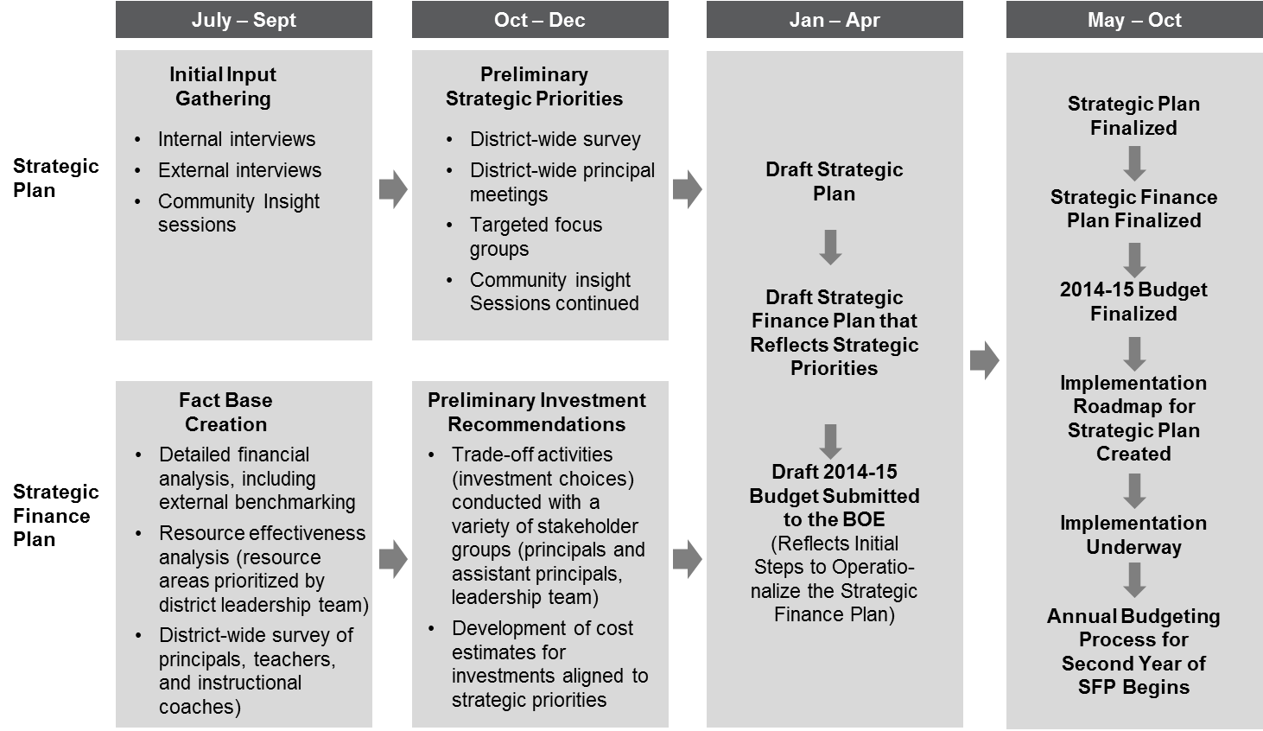
INSTRUCTIONAL PRIORITIES | Details on the district’s instructional priorities and related investment areas that the district has chosen to support with additional resources
This section should provide a comprehensive summary of the district’s instructional priorities and related investments. A proposed structure for this section with related key questions is below:
- Introduction to instructional priorities
  - What does “instructional priority” mean?
  - How does your district identify instructional priorities?
  - What foundational vision or principles underlie your district’s decisions?
  - How will instructional priorities contribute to your student learning goals?
- Specific areas of investment within the instructional priorities
  - How did your district narrow in on these specific investments?
  - List the identified investment areas with short explanations for each
- Graph explaining the additional cost that the investment areas would require over the next three years
- Graphs or charts outlining the student outcome goals for the different priorities
- In-depth description of each investment area, including:
  - What is the need? The need within your district that this investment will seek to address.
  - Why this strategy? The greater district strategy that this investment will support.
  - What will the district do? Details on the investment, what it will allow for, how the program operates, etc.
  - What will it cost? Total annual cost for the next three to five years, outlining start-up costs, annual costs, and ongoing costs.
  - What student gains does the district expect? The gains in student performance your district expects as a result of this investment and why.

Sample Graph of Investment Area Costs:

PAY FOR PRIORITIES | Detail on the opportunities identified to pay for the district’s instructional priorities
This section should provide a comprehensive summary of your district’s identified areas of budget realignment. A proposed structure for this section with related key questions is below:
- Introduction to resource realignment
  - What does it mean to be a “resource realignment” strategy?
  - How did your district identify these areas?
- Recap of financial need in the district
  - How much will your district spend over the next three years including the instructional priorities?
  - How much are revenues projected to change over the next three to five years? Is there a budget deficit that the district needs to address?
    - See Sample Graph
  - Between projected revenue and spending, how much additional investment does your district need to support traditional operations as well as the instructional priorities?
    - See Sample Graph
- List of resource realignment strategies, including projected savings and details on the proposed actions taken to achieve savings
  - Each realignment strategy should detail with as much information as possible about any services or activities that will be discontinued or reduced that do not contribute to student learning gains and/or would not negatively impact student outcomes
- Graphical summary of the combined cost savings over the course of the next three to five years with breakouts to show where the savings come from

Sample Graph of Budget Gap:

Sample Graph of District Projected Budget Need:

Sample Graph of Budget Realignment Opportunities:

Sample Graph of Strategic financial plan Projections:

TRACKING PROGRESS | Details on the plans your district has in place to continue the efforts of the strategic finance process and to track the progress of the proposed initiatives
Explain the measures your district will take to monitor the progress of the strategic financial plan by addressing the following key questions:
- What are the steps your district will take to monitor progress?
- Is there an associated calendar with those activities and actions?
- Which metrics will the district track?
- How will the information be communicated to different stakeholders?
- How will the district continue to seek the input from stakeholders?
- How will the information be reviewed and incorporated to improve a future strategic financial planning process?

Sample Metrics to Track:
Effectiveness of resource use
- % of budget realigned from all opportunities toward instructional priorities and baseline gap
- % of planned realignment realized per opportunity ($ realigned divided by $ planned to realign per opportunity)
- % of planned investment realized per priority ($ invested in each priority divided by $ planned to invest)
- Narrative of successes and barriers in realizing opportunities
- Performance on established return metrics by priority
- Narrative of successes and barriers around priorities: implementing, achieving returns, meeting program goals

Resource allocation process
- Narrative about degree to which strategic financial plan process was followed: priorities determined, specific tradeoffs identified, opportunities prioritized & chosen
- On-time completion of critical milestones by all district initiative teams (yes or no)
- Regularly scheduled School Board updates in place for resource allocation process throughout the year
- Description of how a broader set of teachers, school leaders, and district leaders were involved in the work of resource alignment for the year
- Solicitation of community ideas prior to drafting of strategic financial plan (yes or no)

Resource allocation culture
- % of principals, teachers, and community members who are aware of resource alignment effort
- % of principals, teachers, and community members who see a difference in the extent to which district leadership are focusing resources on instructional priorities
- % of district leaders proficient in using cost/return on investment tools and processes

Student Outcomes
- Narrative about how the financial investments will lead to better student outcomes through the instructional priorities investments
- Summary of metrics and goals for each priority
- Description of how priorities will be implemented and evaluated
- Summary of qualitative changes that will take place as a results of the priorities

Sample Proposed Evaluation Process:
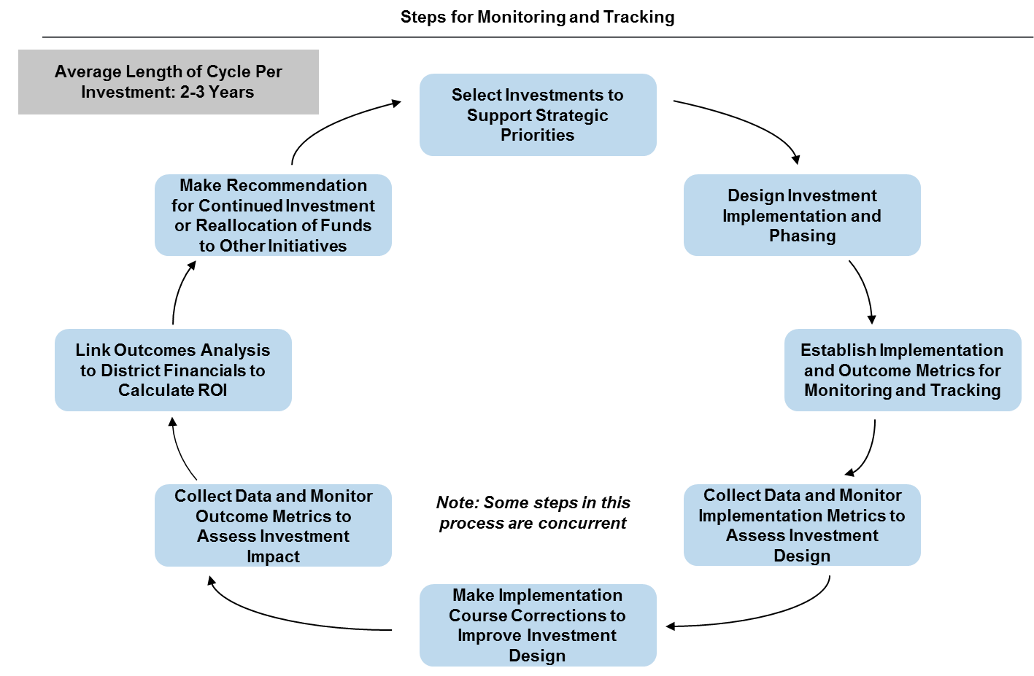
Engage
Stakeholders

APPENDIX | Additional detail about the above sections
The appendix can serve as a section to elaborate on the information presented in the strategic financial plan, specifically for the instructional priorities and budget realignment sections. Some examples of what may be included in the appendix are:
- Additional graphs showing more detail on revenue, spending and costs
- Detailed timelines for the strategic financial plan process, and implementation of the investment priorities
- Analysis of budget realignment opportunities that were not chosen, showing the comprehensive approach the district took

