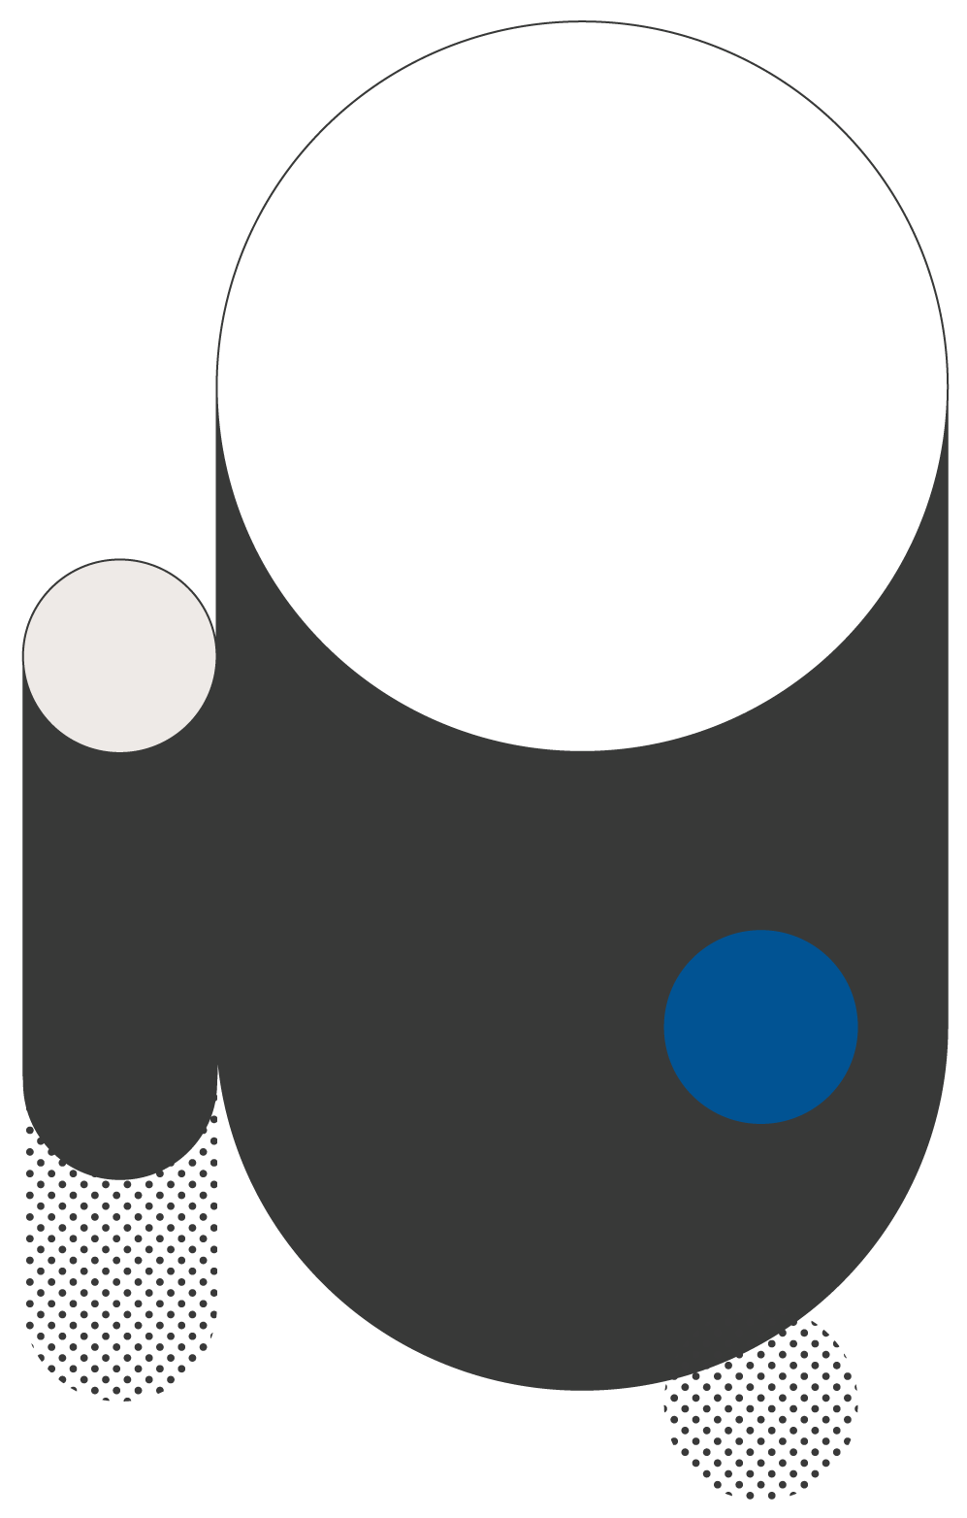
RESERVE POLICY
This template provides the basics of a reserve policy. You should adjust this policy to fit your government’s needs. For further guidance, refer to the GFOA book “Financial Policies.” The book describes the elements in this template plus additional options.

Why a Reserve Policy Is Important
A reserve provides protection from risk. [Name of your government] faces risks like revenue shortfalls during recessions and losses from extreme events, like [relevant examples of natural disasters your government could experience]. Reserves help make sure that [name of your government] can respond quickly and decisively to extreme events. Reserves also support vital public services during revenue declines. A reserve policy describes how much we will try to retain in our reserve. It also describes acceptable uses of reserves.

The Size of [Name of your government]’s Reserve
[Name of your government] will try to hold the following amounts in reserves. The amount of money held in reserve is stated as a percent of revenues. [Expenses can be used too. A government will want to select one that is a reliable indicator of its ongoing budget]. This is so that [name of your government]’s reserve stays consistent with the size of the budget over time.
- At a minimum, the reserve will be equal to at least [X]% of revenues [or expenses]. [The size of the reserves should be based on an analysis of the types of risk your government is trying to manage with reserves. A more general guideline for a minimum is 16% – 17%.]
- The maximum size of the reserves is [Y]% of revenues [or expenses]. [Naming a maximum gives the government a range of reserves to manage within.]
[Name of your government]’s finance department will conduct long-range forecasting to decide if [name of your government] is likely to stay within its range of reserves.
If the minimum reserve is not kept during the forecast period, the [name of position] will develop a plan to bring the reserve to the desired amount. This plan will be offered to [name of elected governing board] for consideration.
If the maximum reserve is exceeded during the forecast period, [name of your government] may spend the excess reserves. Reserves should be treated as a one-time revenue, as per [name of your government]’s policy on one-time revenues.

Acceptable Uses of Reserves
Reserves are meant to address unexpected, nonrecurring costs. Reserves should not be used for recurring annual operating costs. An exception is poor economic conditions or events that disrupt [name of your government]’s revenues. In such cases, reserves may be used to provide short-term relief so that [name of your government] can restructure its operations in an orderly manner.

Authority to Use Reserves
The [decision-maker who has this authority] may authorize the use of reserves for purposes consistent with this policy.

Replenishment of Reserves
If [name of your government] uses its reserves and those reserves are below the allowed maximum, then the [position responsible for managing reserves] will propose a plan for the replacement of the reserves. [Name of elected governing board] will review and approve the plan. [Name of your government] will try to replace the reserves within the minimum amount of time that is practical.

