A Risk-Based Analysis of General Fund Reserve for the Town of Yountville, California

2023

Produced by:
The Government Finance Officers Association

4

Table of Contents
Section 1 - Summary of Findings 3
Earthquakes 5
Wildfires 6
Floods 7
Recessions 8
Cyberattacks 9
Pandemics 10
Section 2 – Detailed Analysis of Earthquake Risk 16
Section 3 – Detailed Analysis of Wildfire Risk 25
Section 4 – Detailed Analysis of Flood Risk 38
Section 5- Detailed Analysis of Recession Risk 45
Section 6 – Detailed Analysis of TOT Interruption Risk 49
Section 7 – Detailed Analysis of Cyberattack Risk 53
Section 8 – Detailed Analysis of Pandemics / Infectious Disease Risk 56

Section 1 - Summary of Findings
About the GFOA
GFOA is a non-profit association of more than 21,000 state and local government finance professionals and elected officials from across North America. A key part of GFOA’s mission is to promote best practices in public finance, including reserve policies.
The Town of Yountville has engaged the Government Finance Officers Association (GFOA) to help the Town analyze its general fund reserve with the goal of shedding light on the appropriate size of the Town’s reserve. This section summarizes our findings and walks the reader through the five steps of the analysis. Here is an overview of the five steps:
- Define “reserves”
- Define the risks the Town is subject to
- Determine exposure to risks
- Put together the findings of risk analysis
- Settle on a reserve target
Shocks versus Stresses
Local government budgets can come under pressure both from “shocks” and “stresses”. Shocks are a sudden, unexpected sharp decline in revenues and/or increase in costs. Recessions and natural disasters are shocks. Stresses are long-term drags on the Town finances that are known problems, but not easily resolved. Pensions or unfunded infrastructure maintenance are examples of these. Reserves are good for protecting against shocks, but not very useful for helping with stresses. This is because shocks are temporary, but stresses can last for many years. Reserves are a non-renewable resource, so are well suited for providing cushion for a shock. The reserve can then be replenished in subsequent years. Stresses, conversely, would eventually deplete a reserve. Therefore, the annual budget is the right place for planning on how to deal with the stresses.
Let’s now examine each step.
The first step is to agree on the definition of “reserves”. We’ll do this by clarifying our “mental model” for reserves. A mental model is a way of viewing the world and simplifying complexity. A traditional mental model for reserves has been the “savings account”. We suggest that this mental model is inadequate. A better mental model is an “insurance policy”. The purpose of a reserve is to provide a financial cushion against unplanned, unavoidable large expenditures, like might be caused by a natural catastrophe, recession, or other extreme event. After all, another name for a local government reserve is a “rainy day fund” and the most common metaphor for an insurance policy is an umbrella!
So, if the reserve is best thought of as an insurance policy, the second step is to ask: what risks are we insuring against? In our personal lives, we answer this question by taking stock of the risks we need to insure against, like automobile accidents, a house fire, etc. For the Town of Yountville, we found that the following risks appear to have the greatest potential to create a big shock to the Town of Yountville’s finances:
Natural Catastrophes, as per Napa County Hazard Mitigation Plan. The County plan lists the three types of catastrophes below as “extreme” or “high” risk for Yountville. We analyzed each of these separately.
- Earthquakes
- Wildfires
- Floods (we also address dam failure)
The Hazard Plan also puts climate change and droughts in this category. We did not analyze these risks here. Climate change is part of this section’s conclusion, where we discuss its potential impact across multiple risks. Though drought is a risk for the Yountville community, the scope of this analysis is the Town’s general fund. A drought’s potential to cause a shock to the general fund seems remote (though one could certainly impact the Town’s water utility). For example, a review of FEMA assistance to local governments since 1999 did not find a single instance of drought being declared a FEMA emergency, where a local government was a recipient of assistance. This illustrates a drought’s limited potential to cause a shock to the Town’s general fund.
Exhibit 1 – Probability and Impact of Natural Catastrophe
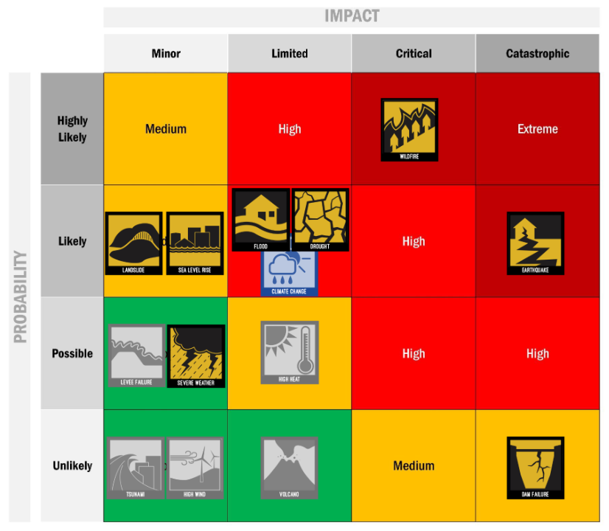
You can see all the risks considered by the County’s Hazard Plan in Exhibit 1.
Revenue Instability
- Recessions
- Interruptions to transient occupancy tax (TOT) revenue. This could be from recessions or from an ill-timed or unfortunately located natural catastrophe, for example.
Other
- Cyberattack
- Pandemic
The third step is to think about the amount of exposure you have to the risks that you face. The amount of exposure is critical to determining the amount of insurance you should have. In our personal lives, we might think about the value of our house and make sure the policy is large enough to cover that cost. For a municipal government, the matter is more complex because not only are there assets that could be damaged by an extreme event, but there might also be increased service costs (e.g., search and rescue, building inspections) or lost revenue. To address this GFOA analyzed each of the risks from step two. We looked primarily at the historical experiences of local governments, mostly in California, to get a sense of what the losses could be.
You can read our detailed analysis of each risk in the subsequent sections of this report, but we will summarize the key points on the next pages.
Readers who would prefer an even more condensed summary can read this paragraph and then skip ahead several pages. We looked at historical data on what the Town and other municipalities have experienced in financial losses from the risks described above. We also looked at other factors that suggest that we should adjust expectations taken from historical experience. We can add up the losses to arrive at a range of possible losses. This range is a starting point for thinking about the Town’s reserve target. The reader may skip ahead several pages to get to the fourth step where we summarize all the losses into one table and to the fifth step where we describe how to develop this range into a final reserve policy.

Earthquakes
Earthquakes are one of the two foremost natural catastrophe risks faced by Town (the other being wildfire – see Exhibit 1). There have been several earthquakes in the region in past decades and there will certainly be others in the future.
To provide insight into potential losses, GFOA examined the actual losses to local governments from earthquakes that occurred in California and Washington since 2000, which ranged in magnitude from 6.0 to 6.8. Earthquakes in this range are expected to result in large amounts of property damage and even some loss of life. Scaling the damage to a community the size of Yountville and adjusting for inflation, the average loss to the Town from such as quake could be expected to be around $12,699. However, much larger losses are possible. For example, our analysis found that in 10% of cases, losses could be over $380,000. In 5% of cases, the loss was greater than $565,000. Of course, we should note that Yountville was a FEMA assistance recipient for the 2014 earthquake. If we converted the Town’s 2014 experience to 2023, the losses would be just over $910,000, making Yountville one of the biggest losses from quakes of all the municipalities we examined.
This shows us that it would be very unwise to rely on “average” losses. In fact, insurance policy decisions never rely on average losses either and, instead, consider the potential for more extreme losses. When put on a graph, these losses create a “hockey stick” shape, as shown in Exhibit 2. This hockey stick shape is common to many types of low frequency, high consequence disasters like earthquakes, wildfires, and floods. As graphic shows, the “average” disaster is very different from what a reserve strategy needs to be concerned with.
Exhibit 2 – The Hockey Stick Shape of Potential Size of Earthquakes
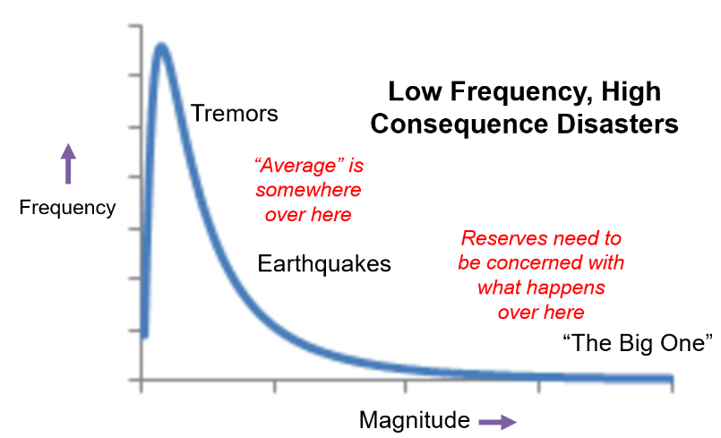
We must recognize that our historical analysis only considered quakes up to 6.8 magnitude. Larger quakes are certainly possible. For example, the infamous 1906 San Francisco earthquake is thought to have been around 8.0 magnitude. Fortunately, we have a basis for estimating the difference in potential damages between the recent quakes (which were between 6.0 and 6.8) and a potentially larger quake. GFOA procured earthquake loss estimates from Aon, a very large, global reinsurance company and purveyor of risk estimates. Aon’s estimates for a two-county area in the San Francisco Bay area shows that estimated losses from a quake above 6.8 is, on average, double, the losses of quakes between 6.0 and 6.8. Hence, doubling our $380,000 number from the previous paragraph would not be unreasonable to prepare for a highly destructive quake – this would give us $740,000. Doubling our 5% loss estimate of $565,000 get 1.13 million also would not be unreasonable. Doubling Yountville’s own experience of $910,000 would yield $1.8 million.
Readers interested in the details behind our earthquake analysis are invited to consult the “Earthquake Financial Risk Analysis” section of this report.
Finally, we should recognize that dam failure is considered an “unlikely” but potentially “catastrophic” risk by the County’s Hazard plan. This refers to the Rector Creek Dam. According to the Town’s website, earthquakes centered close to a dam are typically the most likely cause for failure. Otherwise, the dam is thought to be “in satisfactory condition with no existing or potential dam safety deficiencies”. The earthquake damage figures we provided here do not include potential damages from flooding if an earthquake causes a break in the dam. We will further address this concern in the section on flood risks and in the fifth step of this analysis, which we will discuss later.

Wildfires
Wildfires are the other “extreme” risk faced by Yountville, according to the County Hazard Plan (the other being earthquakes.) Wildfires are common in Napa County. According to the County, “[f]rom 2000-2020, there were 12 wildfires that burned over 1,000 acres in Napa County.
To gain insights into the potential losses from a severe wildfire, GFOA examined actual losses from wildfires severe enough to be declared eligible for FEMA assistance. Just like with earthquakes, we adjusted the damages for inflation and scaled them to Yountville’s population. Also, like earthquakes, wildfire damage tends to follow the “hockey stick” shape shown in Exhibit 2.
The average loss to Town government from a wildfire might be just over $15,500. Because relying on the average is a bad strategy for insurance, we should look at more extreme potential outcomes. Our analysis found that in 10% of cases, losses could be over $215,000. In 5% of cases, the loss was nearly $412,000.
Finally, we should address two additional sources of risk posed by Yountville being a smaller municipality. First, and most basic, is that because it is small, Yountville is, by definition, geographically undiversified. A large municipality might have a much more widely dispersed population, which means a wildfire is less likely to impact large sections of the city. The second risk is that a greater portion of Yountville’s population will be closer to the fuel source for wildfires. By contrast, people who live in the middle of a big city will be much further from fuel sources than those who live near the border of the urban area and combustible wildland areas. People who live in the middle of Yountville aren’t that much further from fuel sources in wildland areas than anyone else in Yountville. In fact, when we examine the FEMA data, we see that municipalities under 10,000 population are susceptible to much higher per capita losses than the municipalities above this number. To be clear, this does not mean that smaller municipalities will always have higher losses per capita than bigger cities – just that smaller cities have a higher chance of experiencing larger losses per capita. This suggests that Yountville might wish to be especially cognizant of the possibility of larger losses.
Readers interested in the details behind our wildfire analysis are invited to consult the “Wildfire Financial Risk Analysis” section of this report.

Floods
The floods are less worrisome for Yountville than earthquakes or wildfires, according to the Napa County Hazard Plan, but are still considered a “high” risk (see Exhibit 1). For example, the First Street Foundation provides hazard estimates for communities across the United States. They describe Yountville’s risk as “moderate”, with 50% of all properties at risk of flood damage over the next three decades. This is a lower risk than First Street assigns to Napa County, as a whole.
Like our previous two losses, GFOA examined actual losses from floods severe enough to be declared eligible for FEMA assistance. Just like the other two, we adjusted the damages for inflation and scaled them to Yountville’s population. Also, like the other two, flood damage tends to follow the “hockey stick” shape shown in Exhibit 2.
The average loss to Town government from a flood might be just under $10,000. Because relying on the average is unwise, we should look at more extreme potential outcomes. Our analysis found that in 10% of cases, losses could be over 105,000. In 5% of cases, the loss was greater than 153,000.
Similar to wildfires, we should consider the implication of Yountville’s small size as it pertains to flood risk. An examination of our data shows that smaller municipalities (under 10,000 population) are susceptible to much higher per capita losses than the municipalities above this population. To be clear, this does not mean that smaller municipalities will always have higher losses per capita than bigger cities – just that smaller cities have a higher chance of experiencing larger losses per capita. This suggests that Yountville might wish to be especially cognizant of the possibility of larger losses.
Finally, we should consider two elements of Yountville’s local context.
First is that Yountville appears to be relatively less suspectable to floods, in general, than some other areas in Napa County. For example, the City of Napa is considered to have “major” flood risk, compared to Yountville’s “moderate” risk, according to First Street’s Risk Factor product. This means that if a flood does occur in the region, then Yountville may be less likely to experience large losses than some other municipalities in the region. This is important because we used historical floods as analogs for what the Town might experience in the future. We should account for the fact that the Town might be more
Exhibit 3 – Rector Creek Dam Inundation Areas
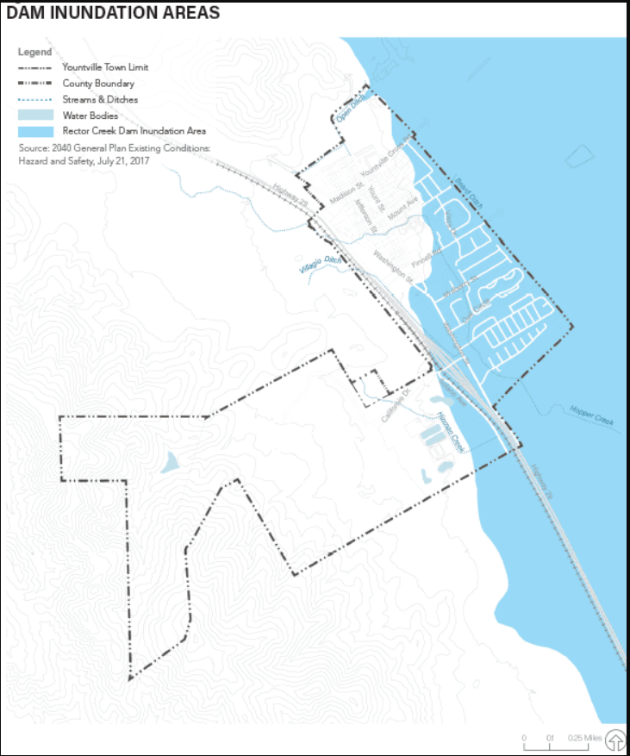
analogous to the municipalities that experienced moderate damage than to municipalities that experienced major damage during those floods.
Second is that the floods we examined all were the result of what we might call “natural” occurrences (e.g., too much rain). Yountville is also at risk of dam failure, where the most likely cause of dam failure is thought to be an earthquake. We might consider this an “unnatural” flood since the dam is man-made. Hence, we need to account for the fact that the Town may face this unique risk of flooding, compared to many of the other municipalities we examined. Exhibit 3 shows the areas the Town thought to be at risk of inundation, should the dam break. We do not have data to be able to estimate the damages from a dam break, but it is probably reasonable to assume that the damages could be on par with some of the worst per capita damages we found from “natural” floods. We saw that the top 5% worst damages were all upwards of $150,000 (scaled to Yountville) and went as high as almost $300,000. Readers interested in the details behind our flood analysis are invited to consult the “Flood Financial Risk Analysis” section of this report.

Recessions
Like all local governments, the Town faces risk of revenue losses due to recession. The transient occupancy tax (TOT) is, by far, the most important revenue for the Town, which means we should be especially cognizant of the risk that recessions pose to TOT. To get a sense of the risk we looked at the experiences of other municipalities in the region because the Town’s tax base has changed dramatically since the last (2008) economic recession. We were able to obtain detailed data about the City of Napa’s experience in the 2001 and 2008 recessions. Napa’s data suggests that TOT is relatively resilient against recession, compared to some other revenues like building permits or even sales taxes. This might be because the Napa region is very attractive to tourists. The data we obtained from Sausalito and Windsor was not as detailed but supports this conclusion.
We also used Napa’s experience during the Great Recession to assess the risks to other revenues. We can sum up Napa’s losses in the important revenue categories as follows:
- Property taxes: 6% decline over 3 years.
- Sales taxes: 15% decline over 3 years.
- TOT: 5% decline over 2 years (the second year was flat, rather than decline).
- Charges for service: 18% decline over 2 years.
- Licenses and permits: 50% decline over 2 years.
- Other taxes, business licenses: 11% decline over 2 years.
If we took these same declines and applied them to the Town’s 2023 actual revenues, we would get a decline of $1.3 million or about 9% of total general fund revenues. This would probably represent a conservative approach because we are using the Great Recession as the historical analogue, which is the worst recession since World War 2. That said, it might also be argued that because Napa is a larger city with a more diversified tax base, it might be less vulnerable to recessions than Yountville. Hence, using the experience of the Great Recession might be less conservative than it first appears. Thus, a $1.3 million to $1.5 million reserve might represent a conservative approach for the Town. A recession like the 2001 recession was mild by historical standards. A smaller reserve would be sufficient to cover that recession, with $1 million still representing a healthy amount.

TOT Interruption Risk
In the prior section, we discussed how recessions could impact the Town’s general fund revenues, including TOT. Economic recessions are not the only way TOT could be interrupted. To illustrate, COVID resulted in the largest decline in TOT the Town and other jurisdictions in the region have experienced in decades. Natural catastrophes could interrupt TOT. Consider the following three examples:
- A strong earthquake damages hotel buildings, making them unoccupiable for a period.
- A wildfire causes a lot of smoke, dissuading tourists from visiting.
- A large flood (like from a dam failure) inundates hotel properties.
To provide insight into the potential risk, we looked at two sources of data. First was the historical patterns of TOT revenue, including those in other municipalities in the region. We looked at the following municipalities, in addition to the Town itself: Napa, Larkspur, Windsor, and Sausalito. Looking across these municipalities we see two consistent interruptions in the TOT trendline.
The first and most obvious interruption was COVID. The following table summarizes the trend in each municipality during Covid.
Municipality | 2020 Decline | 2021 Decline | 2022
Yountville | 25% | 15% | Beyond full recovery
Napa | 26% | 30% | Beyond full recovery
Larkspur | 32% | 41% | Partial recovery, full recovery in 2023
Windsor | 24% | 6% | Beyond full recovery
Sausalito* | 20% | 15% | Has not recovered
*Sausalito’s TOT appears to have entered downward trajectory well before 2020, so we should be careful about interpreting the failure of Sausalito’s TOT to recover to pre-COVID levels.
A second interruption to TOT occurred in 2017. Though this interruption was much smaller than COVID, there does seem to be a consistent downward movement in the trendline around this time. It was not possible for us to know the cause of this dip for sure, but it was consistent across the municipalities. There was a large wildfire in the region around that time, so it seems reasonable to conclude that this fire dissuaded some tourists for a period of one year.

The table below summarizes the temporary declines in each municipality during this one-year period.
Municipality | Year Over Year Decline
Yountville | 11%
Larkspur | 3%
Windsor | 9%
Napa did not experience a decline, but revenue growth did slow down. Sausalito entered a long-term decline right around this time, so it is hard to say how much was due to fires versus other factors.

Let’s now move on to the location of hotel properties in Yountville to see if they are at greater relative risk from natural catastrophes compared to other parts of Yountville.
First, we assume all properties are at the same risk of earthquake, meaning the magnitude of the earthquake will not be different in one part of Yountville versus another. That said, we have insufficient data on building construction to say if the hotels have building features that make them more resistant to earthquakes. Since many of the hotels are relatively new, they may have more modern building features. There may also be soil differences across Town that make some areas more prone to liquification than others. Unfortunately, we do not have access to data on soil conditions under the hotels versus other parts of Yountville.
That means we will focus our attention on wildfires and floods, where there is useful data available. First, we entered each hotel’s address into First Street’s Risk Factor, which gives flood and fire risk by address. We found that no hotels had greater relative risk than Yountville overall and may be slightly less at risk for flood.
The First Street data set is very unlikely to include the risk of inundation from dam failure, so we examined that separately. By examining relevant maps, we found that if a dam failure occurred, the event would mostly affect the southeastern portion of the Town. When comparing the location of the Town’s hotels to the Dam Inundation Map, some hotels may fall within the potential flooding zone. That said, we must remember that the County Hazard plan considers a dam failure to be “unlikely”.
In summary, the historical data shows that interruptions to TOT from events other than recessions are quite possible. In the case of COVID the losses were substantial (COVID is examined in more detail later). The 2017 losses were much less but were noticeable. The good news is that hotel properties in Yountville do not appear to be at more relative risk than the rest of Yountville from floods or wildfires.
For a reserve strategy, a less conservative approach might prepare for something on the scale of 2017 (an 11% decline). A more conservative approach would prepare for something larger. However, we should also remember that pandemics are analyzed as a separate risk, so we also don’t want to “double count” this risk. Hence, a more conservative approach might prepare something larger, but also combine preparation for an interruption from fire, flood, or earthquake with preparation for other more extraordinary sources of interruption, like a pandemic. In this case, the amount might be equal to the pandemic amount we describe later in this report, but in combination with that amount, not in addition to that amount.

Cyberattacks
The Town currently has coverage under “Information Security & Privacy Insurance with Electronic Media Liability Coverage” along with a “Breach Response Endorsement.” GFOA is not an insurance analyst, and a comprehensive review of all policy details was outside the scope of our project, but we can offer some insights from our review of the policy, as it relates to the Town’s reserve strategy.
The insurance has a $2 million limit. There are also several sublimits for different kinds of coverages. For example, there is a $500,000 limit for “Business Interruption Loss Resulting from System Failure”. It is conceivable that a particularly bad attack could exceed one or more of these sublimits. Losses over these sublimits might be covered using the Town’s reserves.
There are also deductible for the approximately 20 different types of coverages in the Town’s policy. A cyber-attack may trigger multiple types of coverages. It is unclear if the Town would have to cover each deductible for each coverage separately. If so, the Town could face substantial deductible costs from a large cyber-attack.
Cyberattacks can cause many types of losses. As mentioned above, the Town’s policy includes several types of coverages to address different losses. Nevertheless, cyber policies are rarely, if ever, comprehensive of every cost that could arise from every cyberattack scenario. Examples of risks not included in the Town’s policy include: acts of war, property damage, and the cost of upgrading computer systems beyond where they were before the attack, as might be necessary to provide better security in the future.
GFOA is not suggesting the Town should have insurance coverage for all risks that could arise from a cyberattack. Such a policy might be cost prohibitive or even completely unobtainable. The Town, though, should be cognizant of what risks the Town is not commercially insuring because those risks are then being, de facto, self-insured.
According to the Town’s IT Administrator, the Town stays up to date with nationally recognized cyber security recommendations. The Town also is diligent about running backups of internal servers, services, and files. First, this should help reduce the risk the Town faces from cyberattacks. Second, cybersecurity requirements do change as attackers evolve their methods. The Town should remain open to investing in additional cost-effective cyber controls to help mitigate future risks.
Because the costs of cyber risk are variable it is hard to estimate an amount to hold for a reserve with the available data. The Town’s current policy does cover many kinds of cyber risks. The Town’s “retained” risks appear to be:
- The deductible costs, especially if the Town is responsible for covering multiple deductibles.
- Damages in excess of the sublimits under any of the individual coverages.
- Uncovered risks, which should be remote relative to the risks that are covered.
GFOA has observed that $1 million is a common limit on cyber policies. Given that most risks are covered by the commercial insurance policy, a conservative approach might take $1 million as a starting point and reserve some fraction of that for retained risks, which will place at $250,000 for discussion purposes. A less conservative approach would be to rely exclusively on the Town’s commercial insurance and its strong preventative posture and not hold additional reserves for cyber risk.

Pandemics
COVID-19 has made people more aware of the risks posed by pandemics. Though pandemics are rare, there are good reasons to remain cognizant of the risk. For example, easier travel means that infectious diseases could spread more easily in the future. Global climate change could create environments that are more hospitable to disease carrying organisms.
There are two types of financial losses the Town could incur from a pandemic: increased costs and decreased revenues. The Town’s experience from COVID suggested that the potential for increased expenditure was not unmanageable (less than $50,000). This is understandable given the Town does not have the same public health responsibilities as Napa County, for example. As for revenues, the potential losses are much larger. If we look at the Town’s $12.6 million in general fund revenue in 2019 and compare it to 2020 actual revenues of $10.5 million, we see that the Town has just over $2 million less in revenues in 2020 compared to 2019. Revenues continued to decline in 2021 – general fund revenues were $9.7 million. Comparing the 2019 revenues of $12.6 million to $9.7 million yields a gap of almost $3 million. If we add that to the $2 million decline from 2019 to 2020, we arrive at about a $5 million total gap between actual annual revenue and what we might have expected the General Fund to take in, during those two years, under a conservative estimate. Most of the general fund decline is attributable to TOT since that is the Town’s largest revenue.
We should also consider the potential for federal support. First, support is not guaranteed. During COVID, it did not appear that federal support for local governments was a forgone conclusion, so we shouldn’t assume federal support will be available in a future pandemic. Second, we shouldn’t assume such support, if it did materialize, would replace all or even most of the Town’s losses. The Town received just over $750,000 in federal funds during COVID, compared to a total loss to the Town of about $5 million. Thus, the Town should consider how its reserve could help buffer against a pandemic. The historical losses from COVID-19 would be reasonable analogue for a future pandemic. Finally, we should recognize that even if pandemics are more likely in the future than they were in the past, they are still quite rare. Therefore, a much less conservative, but still justifiable, approach to this risk could be to reserve something much less than the historical experience.
Let’s now end our review of the risks the Town faces and move to the fourth step, which is to put the findings of the risk analysis together. The table below summarizes the dollar amounts from each risk.
Summary of Low and High Prospective Losses from Risks Town Faces
Natural Catastrophe | Low Impact | High Impact | Notes
Earthquake | $380,000 | $1.8 million | - Low impact represents 10% of loss cases being larger than this number, for a 6.0 to 6.8 quake.  - High impact represents Yountville’s prior actual loss scaled up to a quake above 6.8 magnitude.
Wildfire | $215,000 | $412,000 | - Low impact represents 10% of loss cases being higher than this number.  - High impact represents 5% of loss cases being higher than this number.  - Yountville’s small size suggests vulnerability to larger losses
Flood | $105,000 | $153,000/ $300,000 | - Low impact represents 10% of loss cases being higher than this number.  - Yountville’s small size suggests there may be vulnerability to larger losses, but Yountville may also be relatively less vulnerable to floods than some of the municipalities that were used as analogs.  - The possibility of dam failure suggests the need to be cognizant of the potential for catastrophic losses.  - High impact represents 5% of loss cases being higher than this number and includes the maximum observed loss as a point of reference.
Recession | $1 million | $1.5 million | - The high amount shows an analogous loss to what the City of Napa suffered during the 2008 Great Recession.  - The 2008 recession was the worst since World War 2. The Town could prepare for a milder recession by reserving our lower amount.
TOT Interruption | $1 million | See pandemic risk | - The low amount represents preparing for something analogous to the 2017 experience.  - The high amount would combine this risk with the pandemic numbers.
Cyber Risk | $0 | $250,000 | - The Town has a $2 million insurance policy with sublimits for different types of coverages within the policy  - Using reserves to invest in better cybersecurity controls, as needed, could be worthwhile.  - The low amount represents relying on the Town’s commercial insurance and strong preventative posture.  - The high amount represents a fraction of common limit for commercial insurance policies to cover the Town’s retained risk.
Pandemic | $2.3 million | $5 million | - High represents the complete COVID loss.  - Low represents about a one year’s worth of COVID impact.  - Federal assistance is not included because even if received, it would likely not be immediate.  - Note that both numbers are based directly on historical experience. A less conservative approach, due to the rarity of pandemics, would be to reserve less than either amount. Town officials’ appetite for risk will be important for deciding how conservative, or not, the Town will be.
See following text for totals…
We see the total is about $3.7 million (low) and $9.3 million (high).
This leads us to the fifth and final step, which is for Town Officials to settle on a reserve target. GFOA cannot tell the Town what the precise “correct” amount is because the Town officials’ risk appetite is key to making this determination. If Town officials are risk averse, they might prefer a higher amount. If they are not, they might prefer a lower amount. Regardless, GFOA believes there is much to recommend selecting a target range rather than a single number. There is a good chance that different Town officials have different appetites for risk. A range can accommodate those differences. Also, a range is more useful for monitoring reserve levels because if the reserve falls out of the range the course of action is clear – either replenish the reserves if they are too low or direct them to some other purpose if they are too high. Conversely, a single number is more difficult to manage to. Reserves will rarely, if ever, equal the target exactly. Hence, it is not clear when action is required.
Before settling on a range, Town Officials can consider other factors that might influence their conclusion.
Perhaps the most obvious is the potential for assistance from the Federal Emergency Management Agency (FEMA) and/or the California Governor’s Office of Emergency Services (CalOES). While the financial support these agencies provide could be substantial, it is unlikely to be immediate. For example, a GFOA survey of local governments who were in federally declared disaster areas waited an average of 18 months to receive money from FEMA. This means that federal/state support should not be seen as a substitute for the Town’s reserves, but rather as way to replenish them in the case of an extreme event.
Next, we should recognize that it is unlikely that all the risks we considered will happen at once. This means that the Town probably doesn’t need reserves sufficient to cover 100% of possible losses all at the same time. This means the Town Officials could have some justification for accepting some risk when setting their preferred target. That said, we should recognize that the risks are not totally unrelated either. For example, a wildfire might keep tourists away resulting in both direct losses from wildfire damage/response and losses in TOT revenue. A larger earthquake could trigger a dam failure and catastrophic flood. Or, though the risks may be less likely to happen simultaneously, they could happen within a close enough time period that the Town is unable to fully replenish its reserves from the first loss.
We should also recognize that our analysis is largely based on historical data. One of the most important limitations of this is that climate change may make some kinds of natural catastrophes more likely or more severe, with wildfires being the most salient example in Yountville. This may be a reason for a more risk averse reserve policy by Town Officials.
Another factor to consider is risks that are sometimes called “unknown unknowns.” These are risks that are totally unanticipated. For example, ten years ago no one was talking about cyberattacks as a risk that could seriously impact local government finances. The reality that some risks are unknown unknowns might call for Town officials to choose a more risk adverse range, to make some allowances for unknown unknowns.
The Town’s small size is also a consideration. We addressed this under the discussion of wildfires and floods specifically, but the same general idea applies to the Town’s risk profile, in general. A small municipality is less geographically diversified. This means a given catastrophe may be more likely to impact a larger part of the Town, the tax base is less diversified, etc. Less diversification increases vulnerability to risk.
The Town is highly dependent on transient occupancy tax (TOT). TOT makes up well over half of the general fund revenues. TOT risk is also linked to many of the other risks we have discussed. A recession would reduce people’s available income for travel. A natural catastrophe might discourage people from visiting the area or even damage a hotel. A pandemic could reduce, or even shut down completely, travel.
The Town can cut costs in response to a revenue loss or expenditure shock. For example, during recession local governments very rarely replace every lost dollar of revenue with reserves. The same applies to other extreme events. For example, if a natural catastrophe raises costs in some areas of the Town budget, the Town might be able to at least partially offset it with cuts to other spending. The Towns’ Finance Director suggests that cuts of 3.5% to 4.5% are reasonable for planning purposes.
The Town’s commercial insurance program can provide some coverage against some of the risks we discuss in this report. For example, property insurance might cover earthquake damage to Town Hall. Insurance payouts would presumably happen faster than FEMA reimbursements, for example, so insurance might serve as a substitute for self-insurance by reserves, to some extent.
The final consideration is opportunity costs. Opportunities costs are the benefits the Town is giving up by keeping money in reserve and not using it for other purposes. For example, when GFOA works with large cities that have pressing social problems, officials often feel there are high opportunity costs – money could be used to enhance public safety, health, etc. Unfortunately, there is not yet a good way to measure opportunity costs in local governments, but Town officials should consider alternative uses and how compelling those uses are compared to preparing for risks like those described in this report. Also, the Town should consider some of the secondary benefits of reserves, such as interest income and bond rating increases (to the extent the Town is a potential borrower and would need a bond rating).
The table below summarizes the additional considerations we just described. Town officials should combine this information with the prospective losses from the risks the Town faces, as described earlier. Town officials should then take some time to think about how their risk appetites might influence how much they think the Town should hold in their “insurance policy” or reserve. The decision can then be formalized in a financial policy that accomplishes the following:
- Distinguishes between the “insurance policy” function of reserves and other “savings accounts” that the Town might establish for other purposes. It is fine to have “savings accounts” to buy a capital asset, to pay for special project, etc. but this is a very different purpose than an insurance policy.
- Establishes a target range of reserves, not a single point.
- Describes the target range as a percentage of the Town’s expenditures, rather than dollar amounts. This allows the target to evolve with the size of the Town’s budget.
- Describes the purposes reserves can be used for. This goes back to the distinction we drew between shocks and stresses. Reserves should be used for non-recurring costs.
- Describes the intention to replenish reserves if they drop below the target range and to direct reserves to other purposes if they get above the target range.
Summary of Additional Considerations
Issue | Implication for Town Officials’ Risk Aversion | Notes
FEMA/CalOES | ←→ | Does not reduce need to hold reserves, but helps replenish faster
Simultaneous Occurrence of Risk | ↓ | Unlikely that all or most risks will happen at once.
Analysis Based on Historical Data | ↑ | Historical data does not account for climate risk
Unknown Unknowns | ↑ | Risk analysis does not include risks we don’t and can’t know about
Small Town | ↑ | As a small municipality, the Town is less geographically diversified, which could make the Town more vulnerable to a large loss.
TOT Dependency | ↑ | The Town is highly dependent on TOT and TOT risk is linked to many of the other risks that the Town is subject to.
Spending cuts | ↓ | The Town can reduce costs in response to a revenue loss or even in response to an expenditure spike. Cuts of 3.5% to 4.5% appear reasonable for planning purposes.
Commercial Insurance | ↓ | The Town’s commercial insurance might provide some coverage that substitutes for reserves
Opportunity Costs | ? | What are alternative uses of the funds and how do those benefits compare to insuring against the risks described in this report?

The remaining sections in this report provide additional details behind our analysis of each risk faced by the Town. If the reader was satisfied with the description of each risk provided earlier, then the reader does not to need to read the following sections.

Section 2 – Detailed Analysis of Earthquake Risk
Napa County’s Emergency Operations Plan (EOP) highlights that earthquakes could have potentially “catastrophic” impacts, and that they are “likely” to occur (See Exhibit 1 below). “Catastrophic” events are classified as having the potential for a “high number of deaths [and/or] injuries… [with] more than 50% of property in [the] affected area damaged or destroyed.” Such an event could render a “[c]omplete shutdown of critical facilities for 30 days or more.” A “likely” event is defined as having a 10% - 100% chance of occurring annually, or one that is expected to occur “several times within your lifetime.”

Exhibit 1 – Probability and Impact of Natural Disaster Events in Napa County

Frequency of Earthquakes in Napa County
To consider potential financial risks from earthquakes, we started by examining the frequency of earthquakes in and near Napa County. Exhibit 2 shows a map of all 4.5+ magnitude earthquakes in the greater Bay Area over the last 50 years (12/31/72-12/31/22) . The starred circles identify earthquakes that have occurred in Napa County during that time.

Exhibit 2 – Mapped Earthquakes in and near Napa County, CA (12/31/72 – 12/31/22)
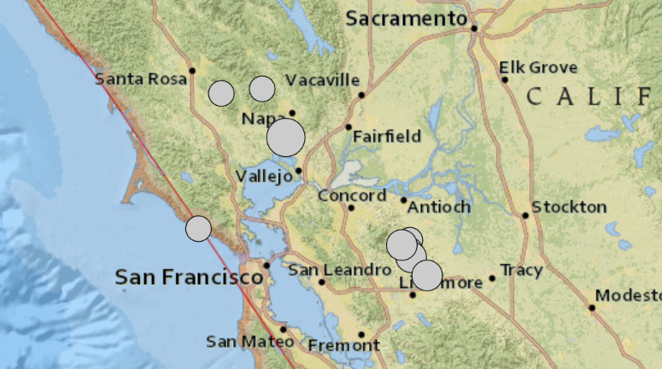
Over that 50-year period (12/31/72-12/31/22), the area in Exhibit 1 had 9 earthquakes that registered a 4.5 on the Richter scale or above. Napa County was hit by two of these “large-scale” earthquakes, one in 2000 and the other in 2014. That equates to an average of 1 earthquake at a 4.5+ magnitude every 25 years in Napa County. Over the same 50-year span and in the same area depicted in Exhibit 1, there have been over 2,000 recorded earthquakes (2,073) that register between 2.5 and 4.4 magnitude (See Table 1 below).
Critically, USGS reports that earthquakes below 6 in magnitude are considered “moderate, light, or minor” and are associated only with minor damage. It isn’t until an earthquake breaks 6.0 on the Richter scale that it is considered a “strong” event by USGS, associated with loss of life and major property damage. Relatedly, despite the frequency of events depicted in Table 1 over the last 50 years, there have only been three earthquake events in California since 2000 that have received presidentially declared disaster status, resulting in FEMA funding. This reinforces that though earthquakes occur frequently around Napa County, “strong” earthquake events that result in major disaster are quite rare.

Table 1 – Earthquake Magnitudes and Frequencies In and Near Napa County (12/31/72) – 12/31/22)
Magnitude | Frequency of Event
2.5-4.4 | 2,073
4.5+ | 9
Total Earthquake Events | 2,082

It should be noted, according to the California Earthquake Authority, there is “a 51 percent chance that the San Francisco region specifically will experience one or more magnitude-7.0 or greater earthquakes [between 2014 and 2044.]” Further, “…there’s a 98% chance of one or more magnitude-6.0 or greater quakes hitting the Bay Area in that same timeframe” (See Exhibit 3 below) .
Exhibit 3 – Earthquake Risk to “Greater Bay Area” (2014-2044)
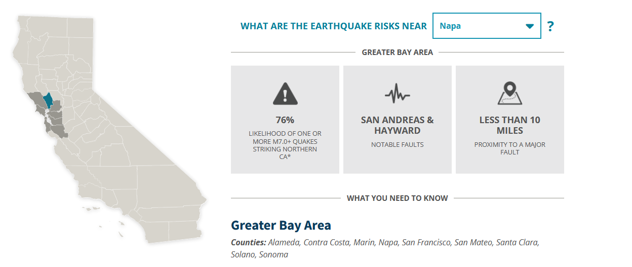
Finally, while strong earthquakes are relatively rare, the potential for a catastrophic event must be acknowledged. The 1906 earthquake in San Francisco was one of the most devastating earthquakes in recorded history. Such a severe earthquake could have devastating effects on the Town’s public health, infrastructure, and economy. Therefore, though infrequent, the possibility of an earthquake of these magnitudes should be accounted for.
Financial Impact on Town Government
The data below represents information obtained from the United States Geological Service (USGS), Napa County’s Emergency Operations Plan (EOP), the U.S. Census Bureau, the California Department of Finance and the Federal Emergency Management Agency (FEMA). There is a focus in Tables 2 and 3 on earthquake events in Californian jurisdictions, including population at the time of the event, FEMA reimbursement, and total losses to a local governments after earthquakes occur. Table 4 includes similar information regarding a 6.8 magnitude earthquake event that occurred in Washington state in 2001.
This information establishes a quantitative method to explore potential losses to Town government from similar events. Understanding the amount of money obligated from FEMA to local governments for an earthquake allows local governments to get a sense of the potential cost of damages associated with similar events (factoring in an assumed 25% local “cost share” with FEMA reimbursement funds). In turn, this information will assist Yountville to consider the amount of reserves the Town should consider keeping on hand to address similar events.
The 2000 earthquake registered a 5.2 magnitude on the Richter scale and resulted in ~$30-$50 million dollars in damages for Napa County. Under the United States Geological Service’s (USGS) criteria, such an event would qualify as a “moderate earthquake” associated with “property damages” (See Exhibit 4 below). Notably, the epicenter of this earthquake was just over 3 miles away from the Town of Yountville. There is no FEMA reimbursement data available to GFOA for this event. The 2014 earthquake registered as a 6.0, resulting in one death and 200 injuries. Associated damages to “[t]he southern Napa Valley and Vallejo areas” were to be between ~$362 million to ~$1 billion for this event. Napa County received ~$4.5M (~$5.7M in 2023 dollars) in reimbursement from FEMA, while the Town of Yountville received ~$493K (~$632K in 2023 dollars). Assuming a 25% local cost share, this brings the total allocation amount for damages regarding the 2014 earthquake to ~$7.1M for Napa County in 2023 dollars and ~$790K for the Town of Yountville in 2023 dollars. Under the United States Geological Service’s (USGS) criteria, the 2014 event would qualify as a “strong earthquake” associated with potential “damage in the billions of dollars and loss of life.” (See Exhibit 4 below).
Exhibit 4 – Earthquake Magnitudes and Associated Energy Equivalents
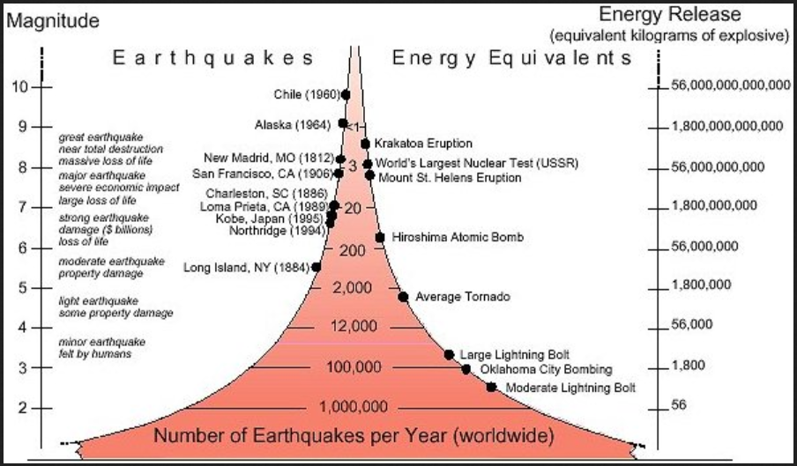

Several California jurisdictions also received FEMA reimbursement for the 6.0 magnitude 2014 earthquake (See Table 2).
Table 2 - 2014 6.0 Magnitude Earthquake in CA and Associated Reimbursements and Losses
Jurisdiction | Total Population  (at time of event) | FEMA Reimbursement (per capita, expressed to the nearest whole dollar, 2023 dollars) | Total Losses to Town/City Gov’t (factoring in 25% local share, expressed in thousands, 2023 dollars)
Napa County | 136,484 | $42 | $7,171K
Town of Yountville | 3,000 | $211 | $790K
City of Calistoga | 5,300 | $1 | $9K
City of American Canyon | 20,300 | $3 | $82K
City of Benicia | 27,800 | $3 | $119K
City of Napa | 79,100 | $157 | $15,538K
City of Vallejo | 119,705 | $5 | $687K

Notably, another 6.0 earthquake impacted other California jurisdictions in 2004. The event also spurred FEMA reimbursements (See Table 3 below).
Table 3 – 2004 6.0 Magnitude Earthquake in CA and Associated Reimbursements and Losses
Jurisdiction | Population  (at time of event) | FEMA Reimbursement (per capita, expressed to the nearest whole dollar, 2023 dollars) | Total Losses to Town/City Gov’t (factoring in 25% local share, expressed in Thousands, 2023 dollars)
City of Guadalupe | 5,900 | $145 | $1,072K
City of Pismo Beach | 8,500 | $3 | $37K
City of Morro Bay | 10,400 | $33 | $430K
City of Arroyo Grande | 16,400 | $2 | $35K
City of Atascadero | 27,400 | $1,218 | $41,707K
City of San Luis Obispo | 44,400 | $0 | $11K
City of Santa Maria | 82,606 | $1 | $59K

Similarly, a 6.8 magnitude Earthquake impacted the State of Washington and several local jurisdictions in 2001. The event also spurred FEMA reimbursements (See Table 4 below).
Table 4 – 2001 6.8 Magnitude Earthquake in WA and Associated Reimbursements and Losses
Jurisdiction (County) | Population  (at time of event) | FEMA Reimbursement (per capita, expressed to the nearest whole dollar, using 2023 dollars) | Total Losses to Town/City Gov’t (factoring in 25% local share, expressed in Thousands, 2023 dollars)
City of Kalama | 1,783 | $12 | $27K
City of Kelso | 11,895 | $1 | $10K
City of Cosmopolis | 1,595 | $30 | $61K
City of Ocean Shores | 3,836 | $3 | $17K
City of Westport | 2,137 | $2 | $5K
City of Bellevue | 109,569 | $8 | $1,000K
City of Bothell | 30,150 | $0 | $1K
City of Raymond | 2,975 | $19 | $72K
City of Sumner | 8,504 | $2 | $16K
City of Anacortes | 14,557 | $1 | $16K
City of Snohomish | 8,494 | $2 | $26K
Town of Rainier | 1,492 | $18 | $34K

Implications for Yountville
Exhibit 5 below represents potential total losses if Yountville was struck by the corresponding earthquake events in the dataset. To create the histogram below, we took the following steps. First, we found the total losses to each town/city government (factoring in 25% local share, in 2023 dollars) effected by one of the three earthquake events in this analysis (2014 – CA, 2004 – CA, 2001 – WA). Next, we divided each of those figures by the population of the effected jurisdiction at the time of the event. That gave us total losses per capita to each town/city government (factoring in 25% local share, in 2023 dollars).
We then used California Department of Finance data to represent Yountville’s current population (2,933) and multiplied that figure by each of the calculated per capita losses to each town/city government in the dataset. These calculations provided plausible total losses for future earthquakes of comparable magnitude and represent the data depicted in Exhibit 5.
Table 5 depicts the key statistics that are represented visually as histogram in Exhibit 5. The dataset included 25 data points, with a range of potential proportional total losses for Yountville calculated to be between $97 and $772,729. This dataset had a median proportional total loss of $12,699, while its 95th percentile figure equated to $567,503, its 90th percentile figure equated to 381,386 and its 10th percentile figure equated to $2,246.
Exhibit 5 – Projected Range of Total Losses if Similar Events Struck Yountville, CA
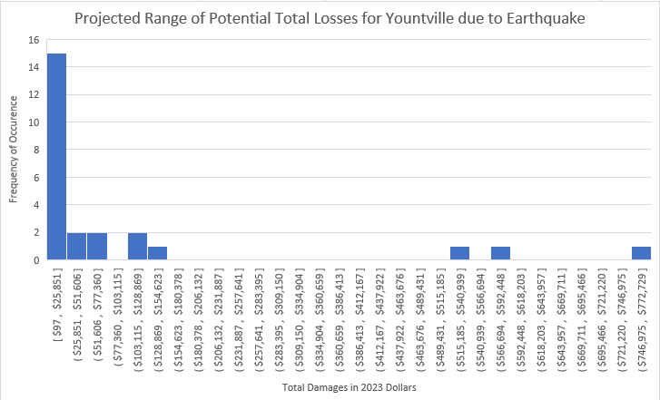

Table 5 – Summary Statistics for Projected Range of Total Losses if Similar Events Struck Yountville, CA
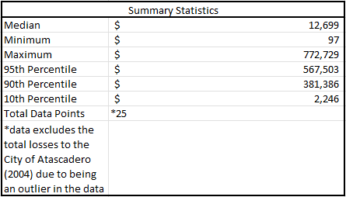

In sum, the totality of data depicted in this analysis allows Yountville to better understand its exposure to potential losses from earthquake events. Further, the analysis provides a quantitative context for expectations regarding the impact of an earthquake on the Town. Tables 2, 3 and 4 each highlight critical elements that may better inform Yountville’s reserve strategy when considering risks posed by earthquakes, including FEMA reimbursement per capita for earthquakes and total losses to local governments after such events (both in 2023 dollars). Exhibit 5 visually summarizes the potential total damage if any of these historic earthquake events were to strike the Town today. In conjunction with Table 5, the Town can use this information to get a snapshot of potential total losses for similar events moving forward and thus make more informed decisions as a local government.

Finally, we must recognize that the numbers in Exhibit 5 only address historically precedented earthquakes. It is certainly plausible that Yountville could experience a more powerful earthquake. Thus, these numbers should not be taken as absolutes, but rather used as inputs for considering Yountville’s reserve strategy.

In the final section of this report, GFOA will bring together all of the individual risk factors for a more comprehensive view of all the risks that influence Yountville’s reserve strategy.

Section 3 – Detailed Analysis of Wildfire Risk
Wildfires have the potential to harm property, livelihoods, and human health. Napa County’s Emergency Operations Plan (EOP) highlights that wildfires could have potentially “critical” impacts, and that they are “highly likely” to occur (See Exhibit 1 below). “Critical” events are classified as having the potential for “multiple deaths/injuries,” with ~25%-50% of property within the “disaster footprint…damaged or destroyed.” Such an event could render a “[c]omplete shutdown of critical facilities for more than one week.” A “highly likely” event is defined as having “100% annual probability[,]” or one that is “likely to occur every year in your lifetime.”
Exhibit 1 – Probability and Impact of Natural Disaster Events in Napa County

Frequency of Wildfires In and Near Napa County
To consider potential financial risks from wildfires, we started by examining the frequency of wildfires in and near Napa County. Exhibit 2 shows a map of all wildfires in the greater Bay Area over a 50-year period (1/1/70 - 12/31/19). Exhibit 3 shows a map of wildfires in Yountville’s local area over the same period. The different colors in Exhibits 2 and 3 correspond to the decade in which the wildfire occurred (Yellow – 1970s; Orange – 1980s; Green – 1990s; Blue – 2000; Purple/Pink – 2010s). Exhibit 4 shows a map of all wildfires in the greater Bay Area over the year 2020 (most recently available data; not included in previous dataset). Exhibit 5 shows a map of wildfires in Yountville’s local area also over the year 2020.
Exhibit 2 – Mapped Wildfires in the greater Bay Area (1/1/70) – 12/31/19)
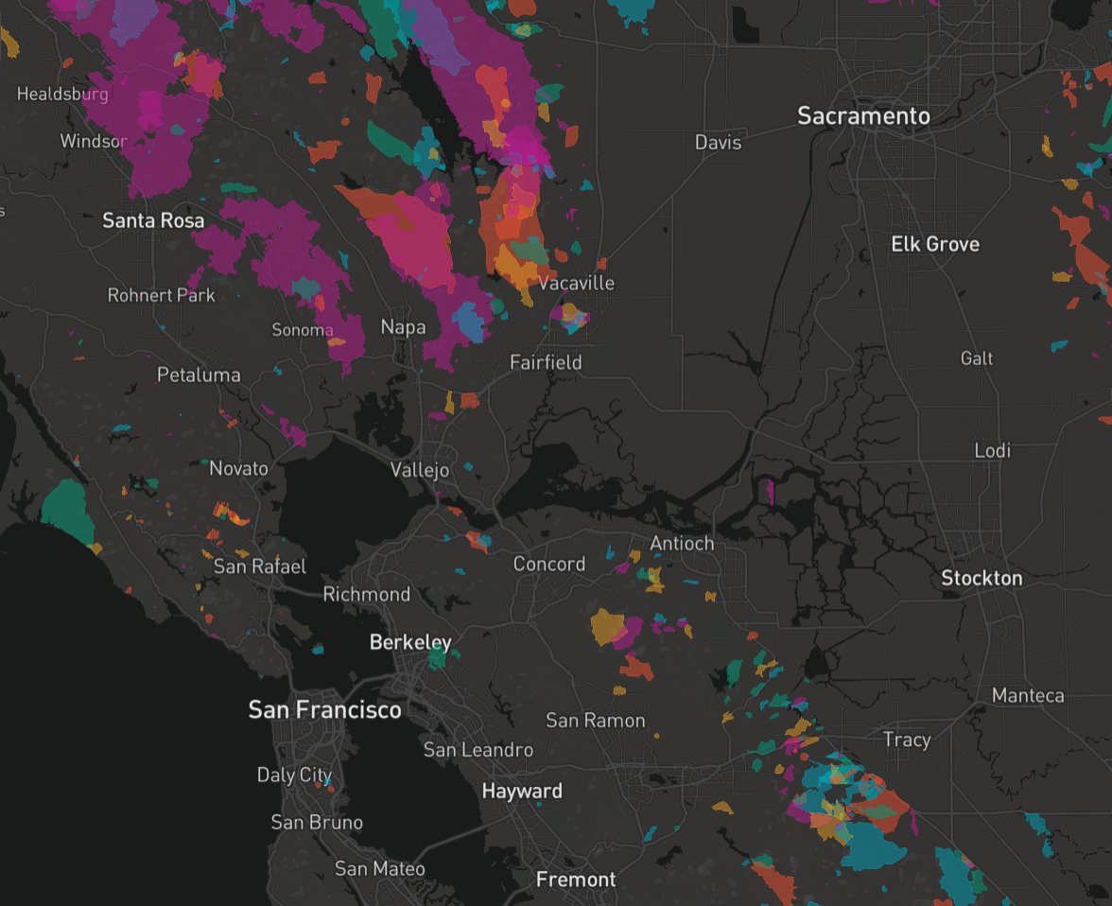

Exhibit 3 - Mapped Wildfires in the local Yountville area (1/1/70) – 12/31/19)
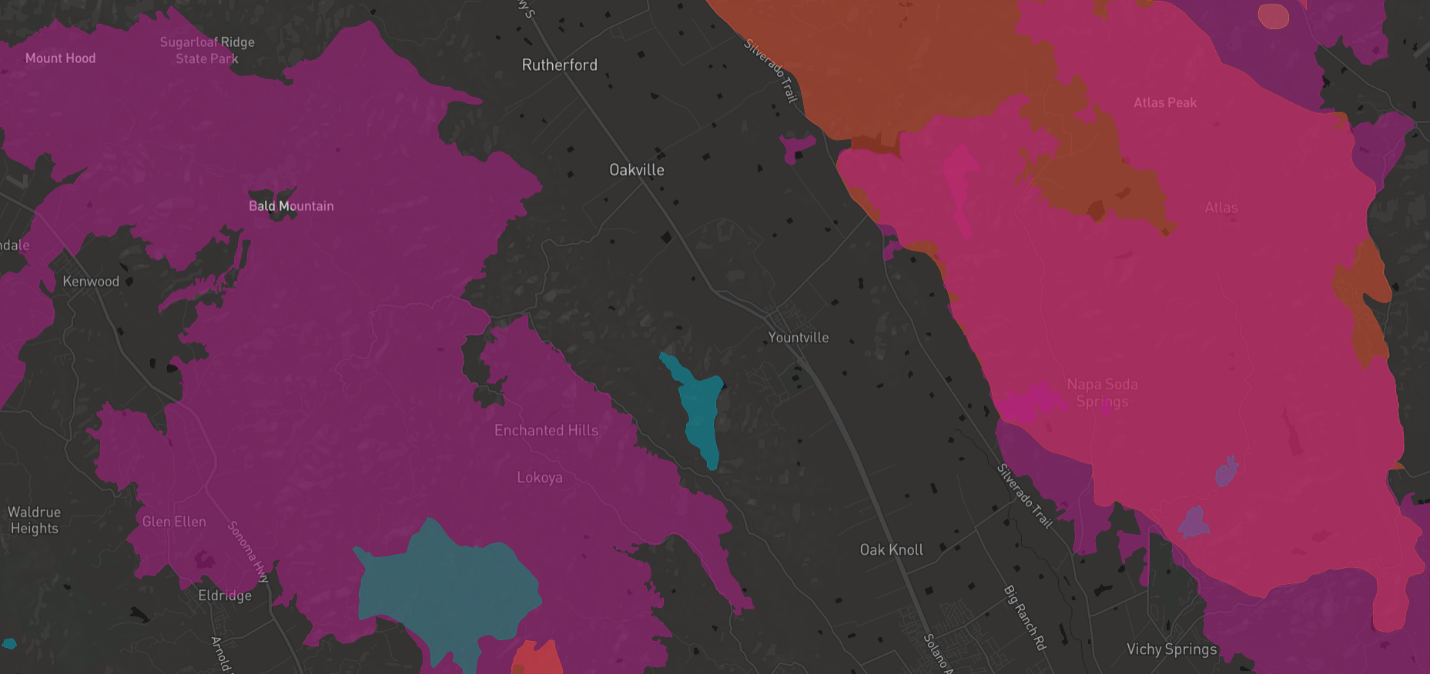
Exhibit 4 - Mapped Wildfires in the greater Bay Area (1/1/20) – 12/31/20)
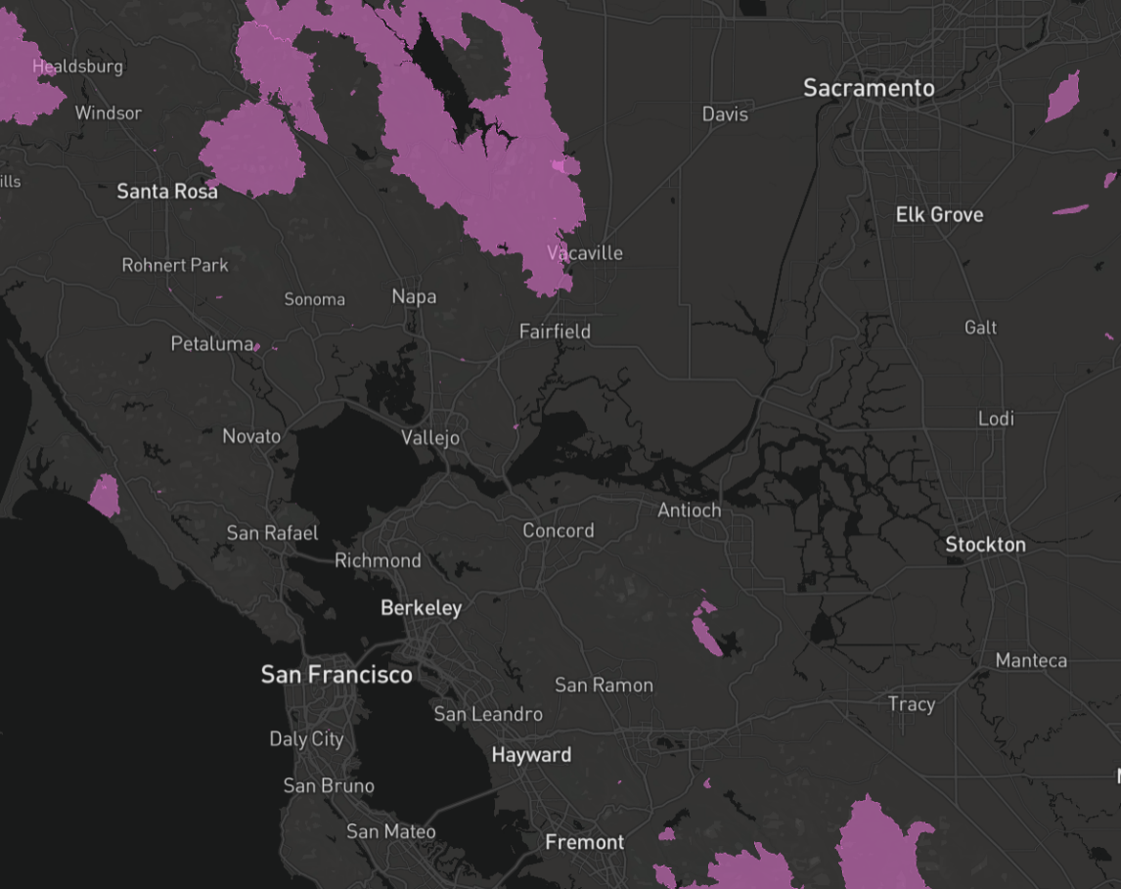

Exhibit 5 - Mapped Wildfires in the local Yountville area (1/1/20) – 12/31/20)
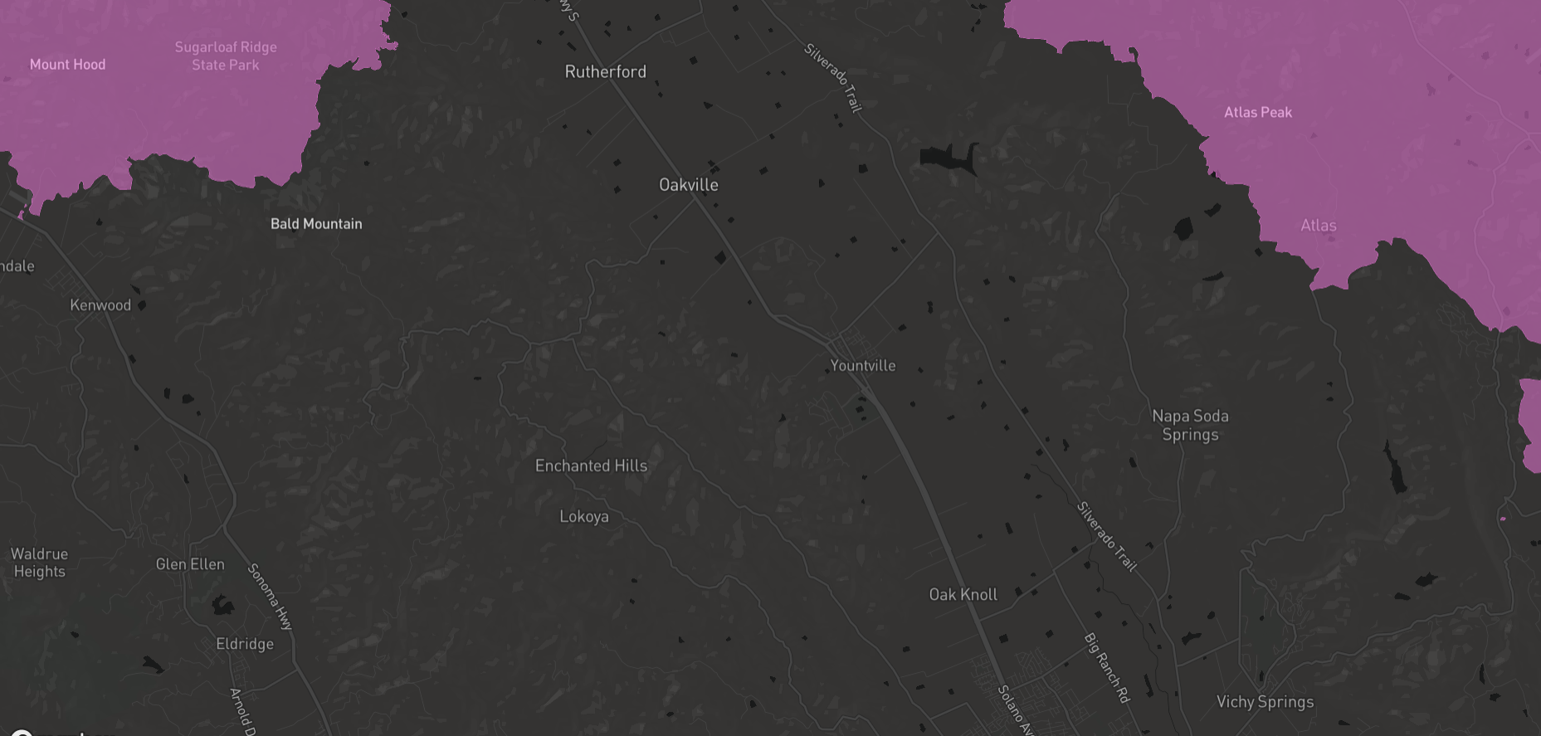
Napa County’s EOP notes, “[f]rom 2000-2020, there were 12 wildfires that burned over 1,000 acres in Napa County.” Extrapolating based on this information over 20 years, there is a 60% chance that a wildfire occurs in Napa County annually. Said differently, this equates to an average of more than one wildfire occurring every two years in Napa County (~1.2 wildfires on average biannually).
Wildfire Severity and Napa County’s Vulnerability
Wildfires are classified by three levels of severity (low, medium, and high). Severity is defined as “a function of intensity, or how hot the fire was, and its spread rate, or the speed at which it travels.” The U.S. Fish and Wildlife Service highlights that wildfires are “inevitable,” and depending on their severity, can provide benefits or harms to the lands they burn. Low severity wildfires have “limited effect on overstory trees (<30% mortality), understory vegetation, and soils.” Wildfires that remain at low intensities can actually benefit wildlife and forest health by naturally “cleaning” thick vegetation from the forest floor, resulting in enriched soil. Medium severity wildfires produce “variable, moderate effects on overstory trees, averaging 30-80% of the vegetation killed, and/or moderate soil exposure.” High severity wildfires result in “a high percent of overstory tree mortality (>80%) and/or extensive mineral soil exposure.” High-severity wildfires can devastate wildlife, ecosystems, resources, and nearby communities. Wildfires that reach this threshold are associated with loss of life, destroyed property, damaged water sources, and disrupted food chains, among other negative externalities.

According to California’s Office of the State Fire Marshall, Napa County has over 350,000 acres within the State Responsibility Area (SRA) that are considered wildfire hazard zones. Notably, ~265,000 of these acres are considered in “very high” fire hazard severity zones. The remaining land within SRA hazard zones are ~78,000 acres in “high” SRA fire hazard severity zones and ~17,500 acres are in “moderate” SRA fire hazard severity zones. Yountville hovers the border of an SRA to the west and a Local Responsibility Area (LRA) to the direct east. See Exhibit 6 below. An SRA area is a legal term defining the area where the State has financial responsibility for wildland fire protection and prevention. Incorporated cities and federal ownership are not included in SRAs. LRAs are incorporated cities, urban regions, agriculture lands, and portions of the desert where the local government is responsible for wildfire protection. This is typically provided by city fire departments, fire protection districts, counties, and by CAL FIRE under contract.
Exhibit __ - State Responsibility Area Fire Hazard Severity Zones in Napa County
Exhibit 6 - State Responsibility Area Fire Hazard Severity Zones in Napa County

Further, according to the First Street Foundation’s Risk Factor tool, the Town has a moderate risk of wildfire over the next 30 years. Their model shows there are over 800 at-risk properties over the next 30 years in the town, representing 99% of all properties in the Town. In other words, this model states that virtually every property in the Town could potentially be affected by a wildfire over the next three decades. These properties include 761 residential properties, 46 commercial properties, 3 critical infrastructure facilities and 8 social facilities. See Exhibit 7 below. Three key factors that contribute to an area’s vulnerability to wildfire events are vegetation and fuel sources, possible ignition sources, and topography and weather. See Exhibit 8 below.
Exhibit 7 - Yountville’s Wildfire Risk in First Street Risk Factor Model
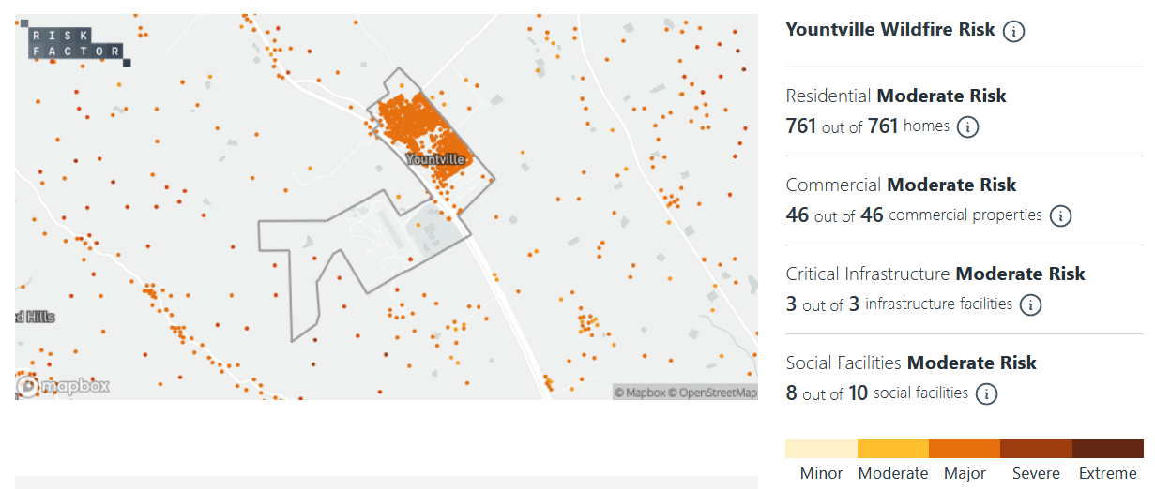
Exhibit 8 - Key Wildfire Vulnerability Factors
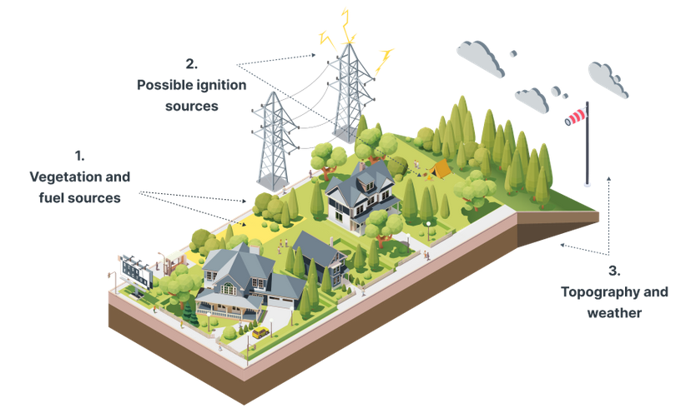
Typically, the late summer and early fall months (August, September, and October) present the greatest potential for wildfire events to occur. This is due to dry vegetation, lower humidity levels and the blowing of offshore wind during these months. However, while these months do remain the greatest threat, due to an increasingly warmer and drier environment, wildfire seasons are extending and becoming “more active.” According to the EPA, multiple studies have linked climate change factors (warmer springs, longer summer dry seasons, and drier soils and vegetation) to lengthened wildfire seasons, increased wildfire occurrence and larger burn perimeters. Continuous high-heat and drought “set the stage for extraordinary wildfire seasons” over the last three full calendar years for which data is available (2020-2022). Each of those three years surpassed the average of 1.2 million acres burned nationally per year due to wildfire events. The trend of increasing threat from wildfire is expected to continue.
Financial Impact on Town Government
The data below represents information obtained from the United States Geological Service (USGS), Napa County’s Emergency Operations Plan (EOP), the U.S. Census Bureau, the California Department of Finance, and the Federal Emergency Management Agency (FEMA). There is a focus in Tables 2, 3, and 4 on wildfire events in Californian jurisdictions, which includes key information like population at the time of the event, FEMA reimbursement, and total losses to a local governments after wildfires occur.
This information establishes a quantitative method to explore potential losses to Town government from similar events. Understanding the amount of money obligated from FEMA to local governments for a wildfire allows local governments to get a sense of the potential cost of damages associated with similar events (factoring in an assumed 25% local “cost share” with FEMA reimbursement funds). In turn, this information will assist Yountville to consider the amount of reserves the Town should consider keeping on hand to address similar events.
The 2017 wildfire resulted in a total of ~$50M dollars in federal reimbursement being allocated across the 17 jurisdictions in the dataset. Napa County received ~$3.697M (~$4.576 in 2023 dollars) in reimbursement from FEMA. Assuming a 25% local cost share, this brings the total allocation amount for damages regarding the 2017 wildfire to ~$5.72 for Napa County in 2023 dollars. See Table 1 below.

Table 1 – 2017 Wildfire Event and Associated Reimbursements and Losses
Jurisdiction | Total Population  (at time of event) | FEMA Reimbursement (per capita, expressed to the nearest whole dollar, 2023 dollars) | Total Losses to Town/City Gov’t (factoring in 25% local share, expressed in thousands, 2023 dollars)
CLEARLAKE | 15,250 | $6 | 119K
UKIAH | 16,075 | $1 | 22K
WILLITS | 4,888 | $24 | 148K
CALISTOGA | 5,155 | $74 | 474K
NAPA | 76,915 | $45 | 4,322K
NAPA (COUNTY) | 136,752 | $33 | 5,720K
SAINT HELENA | 5,814 | $23 | 164K
ORANGE | 136,416 | $4 | 613K
TUSTIN | 75,540 | $0 | 25K
FAIRFIELD | 105,321 | $1 | 81K
VALLEJO | 115,942 | $1 | 211K
HEALDSBURG | 11,254 | $3 | 46K
PETALUMA | 57,941 | $1 | 78K
ROHNERT PARK | 40,971 | $3 | 165K
SONOMA | 10,648 | $7 | 99K
SONOMA (COUNTY) | 484,675 | $62 | 37,722K
WINDSOR | 26,801 | $1 | 39K

The 2018 wildfires resulted in ~$78M dollars in federal reimbursement being allocated to the 15 jurisdictions in the dataset. See Table 2 below.

Table 2 – 2018 Wildfire Events and Associated Reimbursements and Losses
Jurisdiction | Population  (at time of event) | FEMA Reimbursement (per capita, expressed to the nearest whole dollar, 2023 dollars) | Total Losses to Town/City Gov’t (factoring in 25% local share, expressed in Thousands, 2023 dollars)
CARPINTERIA | 13,040 | $15 | 237K
SANTA BARBARA | 88,410 | $28 | 3,094K
OJAI | 7,461 | $4 | 35K
OXNARD | 197,899 | $0 | 46K
SANTA PAULA | 29,321 | $57 | 2,088K
LAKEPORT | 4,753 | $46 | 274K
REDDING | 89,861 | $151 | 16,984K
CHICO | 86,187 | $1 | 161K
OROVILLE | 15,546 | $0 | 6K
AGOURA HILLS | 20,330 | $3 | 73K
CALABASAS | 23,058 | $1 | 25K
HIDDEN HILLS | 1,856 | $16 | 38K
MALIBU | 12,645 | $282 | 4,454K
THOUSAND OAKS | 126,683 | $9 | 1,478K

Similarly, wildfires in 2020 impacted several Californian jurisdictions. The event also spurred FEMA reimbursements (See Table 4 below). Napa County received ~$3.43M (~$4.021M in 2023 dollars) in reimbursement from FEMA after being affected by one of the 2020 wildfires in California. Assuming a 25% local cost share, this brings the total allocation amount for damages regarding the 2020 wildfire to ~$5.027M for Napa County in 2023 dollars. See Table 2 below.
Table 3 – 2020 Wildfire Events and Associated Reimbursements and Losses
Jurisdiction | Population  (at time of event) | FEMA Reimbursement (per capita, expressed to the nearest whole dollar, using 2023 dollars w/ 2000 Census pop. data) | Total Losses to Town/City Gov’t (factoring in 25% local share, expressed in Thousands, 2023 dollars)
OROVILLE | 20,104 | $16 | 395K
MONTEREY | 30,230 | $0 | 10K
NAPA (COUNTY) | 135,965 | $30 | 5,027K
SAINT HELENA | 5,436 | $30 | 205K
DALY CITY | 104,973 | $1 | 112K
MORGAN HILL | 45,481 | $5 | 294K
SANTA CRUZ | 62,968 | $4 | 333K
FAIRFIELD | 119,872 | $4 | 559K
VACAVILLE | 102,386 | $3 | 421K
HEALDSBURG | 11,349 | $2 | 32K
WINDSOR | 26,353 | $1 | 29K
FRESNO | 542,252 | $0 | 140K
ARCADIA | 56,664 | $7 | 471K
MONROVIA | 37,937 | $59 | 2,787K
SIERRA MADRE | 11,275 | $12 | 172K
CALISTOGA | 5,227 | $50 | 324K
SAINT HELENA | 5,436 | $319 | 2,171K
MONTCLAIR | 37,886 | $1 | 42K
REDLANDS | 73,170 | $0 | 14K
YUCAIPA | 54,552 | $0 | 5K

Implications for Yountville
Exhibit 9 below represents potential total losses if Yountville was struck by one of the corresponding wildfire events in the dataset. To create the histogram below, we took the following steps. First, we found the total losses to each town/city government (factoring in 25% local share, in 2023 dollars) effected by one of the wildfire events in this analysis (2017, multiple in 2018 and multiple in 2020). Next, we divided each of those figures by the population of the effected jurisdiction at the time of the event. That gave us total losses per capita to each town/city government (factoring in 25% local share, in 2023 dollars).
We then used California Department of Finance data to represent Yountville’s current population (2,933)¹⁹ and multiplied that figure by each of the calculated per capita losses to each town/city government in the dataset. These calculations provided plausible total losses for future wildfires of comparable magnitude and represent the data depicted in Exhibit 9.
Table 4 depicts the key statistics that are represented visually as histogram in Exhibit 9. The dataset included 51 data points, with a range of potential proportional total losses for Yountville calculated to be between $297 and $1,171,255. This dataset had a median proportional total loss of $15,520, while its 95th percentile figure equated to $411,944, its 90th percentile figure equated to $215,448 and its 10th percentile figure equated to $981.
Exhibit 9 – Projected Range of Total Losses if Similar Events Struck Yountville, CA
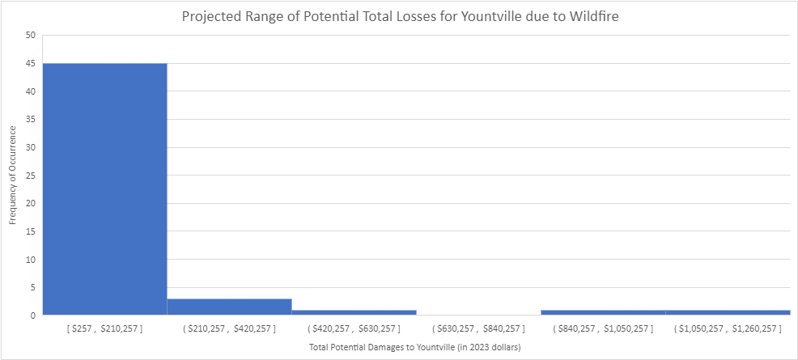

Table 4 – Summary Statistics for Projected Range of Total Losses if Similar Events Struck Yountville, CA
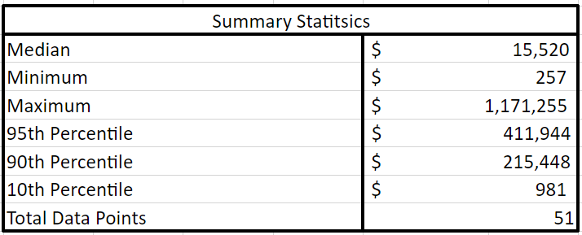

In sum, the totality of data depicted in this analysis allows Yountville to better understand its exposure to potential losses from wildfire events. Further, the analysis provides a quantitative context for expectations regarding the impact of a wildfire on the Town. Tables 1, 2 and 3 each highlight critical elements that may better inform Yountville’s reserve strategy when considering risks posed by wildfires, including FEMA reimbursement per capita for earthquakes and total losses to local governments after such events (both in 2023 dollars). Exhibit 9 visually summarizes the potential total damage if any of these historic wildfire events were to strike the Town today. In conjunction with Table 4, the Town can use this information to get a snapshot of potential total losses for similar events moving forward and thus make more informed decisions as a local government.

Section 4 – Detailed Analysis of Flood Risk
Napa County’s Emergency Operations Plan (EOP) highlights that floods have historically been the most common natural disaster to impact Napa County. The EOP states that floods could have potentially “limited” impacts, and that they are “likely” to occur (See Exhibit 1 below). “Limited impact” events are classified as having the potential for “minor injuries only,” with approximately “10% or less of property in [the] disaster footprint damaged or destroyed.” Such an event could render a “[c]omplete shutdown of critical facilities for more than one day.” A “likely” event is defined as having a 10% - 100% chance of occurring annually, or one that is expected to occur “several times within your lifetime.”
Exhibit 1 – Probability and Impact of Natural Disaster Events in Napa County

Risk of Floods in Yountville
According to the First Street Foundation’s Risk Factor tool, the Town has a moderate risk of flooding over the next 30 years. Their model shows there are over 185 properties with a ~26% chance risk of being severely affected by a flood event over the next 30 years in the town. Furthermore, in total, First Street finds that ~50% of all properties in Yountville are at risk of flood related damages over the next three decades. In other words, this model states that many properties in the Town could potentially be affected by a flood over the next couple generations. These properties include 398 residential properties, 12 commercial properties, and 2 social facilities. See Exhibit 2.
Exhibit 2 - Yountville’s Flood Risk in First Street Risk Factor Model
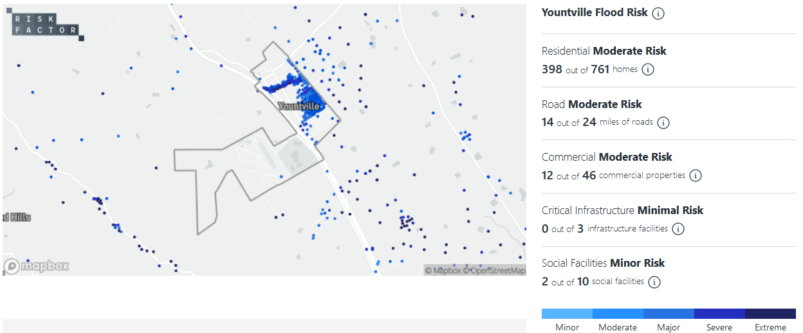
According to Napa County’s EOP, “flood reduction, prevention, and mitigation are [already] a major challenge to Napa County residents and floodplain managers...” At the same time, the plan acknowledges that “many areas of Napa Valley are at risk of flooding, especially low-lying properties near the Napa River and its feeder streams.” The EOP also notes that traditionally, the river has been most prone to flooding between the months of November and April. Notably, the California Department of Water Resources reports that the state is currently experiencing a shift towards a hotter and drier climate. Due to these changes, there is a necessity to prepare for more extreme flooding events moving forward. The First Street Foundation further backs up this report, highlighting that a changing climate is associated with “higher seas, new weather patterns, and stronger storms.” More evaporation, warmer oceans and sea level rise can all contribute to increases in flooding.

Financial Impact on Town Government
The data below represents information obtained from the United States Geological Service (USGS), Napa County’s Emergency Operations Plan (EOP), the U.S. Census Bureau, the California Department of Finance and the Federal Emergency Management Agency (FEMA). There is a focus in Tables 1, 2 and 3 on flood events in Californian jurisdictions, including population at the time of the event, FEMA reimbursement per capita (in 2023 dollars), and total losses to a local governments after floods occur.
This information establishes a quantitative method to explore potential losses to Town government from similar events. Understanding the amount of money obligated from FEMA to local governments for a flood allows local governments to get a sense of the potential cost of damages associated with similar events (factoring in an assumed 25% local “cost share” with FEMA reimbursement funds). In turn, this information will assist Yountville to consider the amount of reserves the Town should consider keeping on hand to address similar events.
Several California jurisdictions received FEMA reimbursement for a 2011 flood event. (See Table 1 below).
Table 1 – 2011 Flood Event in CA and Associated Reimbursements and Losses
Jurisdiction | Total Population  (at time of event) | FEMA Reimbursement (per capita, expressed to the nearest whole dollar, 2023 dollars) | Total Losses to Town/City Gov’t (factoring in 25% local share, expressed in thousands, 2023 dollars)
DELANO | 53,041 | $1.12 | 74K
MCFARLAND | 12,707 | $9.88 | 157K
DANA POINT | 33,351 | $4.60 | 192K
BEAUMONT | 36,877 | $7.20 | 332K
BARSTOW | 22,639 | $5.58 | 158K
GRAND TERRACE | 12,040 | $1.96 | 30K
LEMON GROVE | 25,320 | $0.34 | 11K
SANTEE | 53,413 | $6.56 | 438K
GROVER BEACH | 13,156 | $0.44 | 7K
PISMO BEACH (PISMO) | 7,655 | $38.44 | 368K
SAN LUIS OBISPO | 45,119 | $0.69 | 39K
GUADALUPE | 7,080 | $1.14 | 10K
SANTA MARIA | 99,553 | $0.53 | 65K

Another flood impacted other California jurisdictions in 2017. The event also spurred FEMA reimbursements among the jurisdictions in the dataset. This flood event resulted in ~$696K (2023 dollars) in FEMA reimbursement for Napa County. Assuming a 25% local cost share, this brings the total amount for damages regarding the first 2017 flood to ~$869K for Napa County (in 2023 dollars). (See Table 2 below).
Table 2 – 2017 Flood Event #1 in CA and Associated Reimbursements and Losses
Jurisdiction | Population  (at time of event) | FEMA Reimbursement (per capita, expressed to the nearest whole dollar, 2023 dollars) | Total Losses to Town/City Gov’t (factoring in 25% local share, expressed in Thousands, 2023 dollars)
DANVILLE | 42,039 | $1.41 | 74K
ARVIN | 19,304 | $4.41 | 107K
AGOURA HILLS | 20,330 | $2.35 | 60K
MONROVIA | 36,590 | $1.22 | 56K
MONTEBELLO | 62,500 | $ 1.34 | 104K
MAMMOTH LAKES | 8,234 | $1.06 | 11K
NAPA (COUNTY) | 136,484 | $5.10 | 869K
LAGUNA BEACH | 22,723 | $2.88 | 82K
INDIAN WELLS | 4,958 | $22.82 | 141K
WILDOMAR | 32,176 | $2.47 | 99K
DEL MAR | 4,161 | $2.21 | 11K
SANTEE | 53,413 | $4.69 | 313K
ARROYO GRANDE | 17,252 | $0.19 | 4K
ATASCADERO | 28,310 | $0.57 | 20K
SAN BRUNO | 41,114 | $3.31 | 170K
SCOTTS VALLEY | 11,580 | $4.28 | 62K

Similarly, a separate flood event impacted several jurisdictions in 2017. The event also spurred FEMA reimbursements. This second 2017 flood event resulted in ~$3.1M (in 2023 dollars) in FEMA reimbursement for Napa County. Assuming a 25% local cost share, this brings the total amount for damages regarding the 2017 flood to ~$3.8M for Napa County (in 2023 dollars). (See Table 3 below).

Table 3 – 2017 Flood Event #2 in CA and Associated Reimbursements and Losses
Jurisdiction (County) | Population  (at time of event) | FEMA Reimbursement (per capita, expressed to the nearest whole dollar, using 2023 dollars w/ 2000 Census pop. data) | Total Losses to Town/City Gov’t (factoring in 25% local share, expressed in Thousands, 2023 dollars)
IONE | 7,918 | $1.21 | 12K
SUTTER CREEK | 2,501 | $2.86 | 9K
OROVILLE | 15,546 | $22.42 | 436K
WILLIAMS | 5,123 | $28.87 | 185K
MORAGA | 16,016 | $1.54 | 31K
PLACERVILLE | 10,389 | $32.01 | 416K
LARKSPUR | 11,926 | $45.13 | 673K
NOVATO | 51,904 | $0.19 | 12K
CARMEL-BY-THE-SEA | 3,722 | $3.34 | 16K
MONTEREY | 27,810 | $4.14 | 144K
NAPA | 76,915 | $1.56 | 150K
NAPA (COUNTY) | 136,484 | $22.39 | 3,819K
TRUCKEE | 16,180 | $5.83 | 118K
ARROYO GRANDE | 17,252 | $4.20 | 91K
ATASCADERO | 28,310 | $0.37 | 13K
BELMONT | 25,835 | $1.17 | 38K
GUADALUPE | 7,080 | $1.84 | 16K
SARATOGA | 29,926 | $2.72 | 102K
SCOTTS VALLEY | 11,580 | $0.29 | 4K
CLOVERDALE | 8,618 | $57.15 | 616K
RED BLUFF | 14,076 | $1.41 | 25K
MARYSVILLE | 12,072 | $77.40 | 1,168K
Implications for Yountville
Exhibit 3 below represents potential total losses if Yountville was struck by the corresponding flood events in the dataset. To create the histogram below, we took the following steps. First, we found the total losses to each town/city government (factoring in 25% local share, in 2023 dollars) effected by one of the three flood events in this analysis (2011 – CA, 2017 – CA [1], 2017 – CA[2]). Next, we divided each of those figures by the population of the affected jurisdiction at the time of the event. That gave us total losses per capita to each town/city government (factoring in 25% local share, in 2023 dollars).
We then used California Department of Finance data to represent Yountville’s current population (2,933)¹⁹ and multiplied that figure by each of the calculated per capita losses to each town/city government in the dataset. These calculations provided plausible total losses for future floods of comparable impact and represent the data depicted in Exhibit 3.
Table 4 depicts the key statistics that are represented visually as histogram in Exhibit 3. The dataset included 51 data points, with a range of potential proportional total losses for Yountville calculated to be between $691 and $283,771. This dataset had a median proportional total loss of $9,974, while its 95th percentile figure equated to $153,200, its 90th percentile figure equated to $105,838 and its 10th percentile figure equated to $1,630.
Exhibit 3 – Projected Range of Total Losses if Similar Events Struck Yountville,
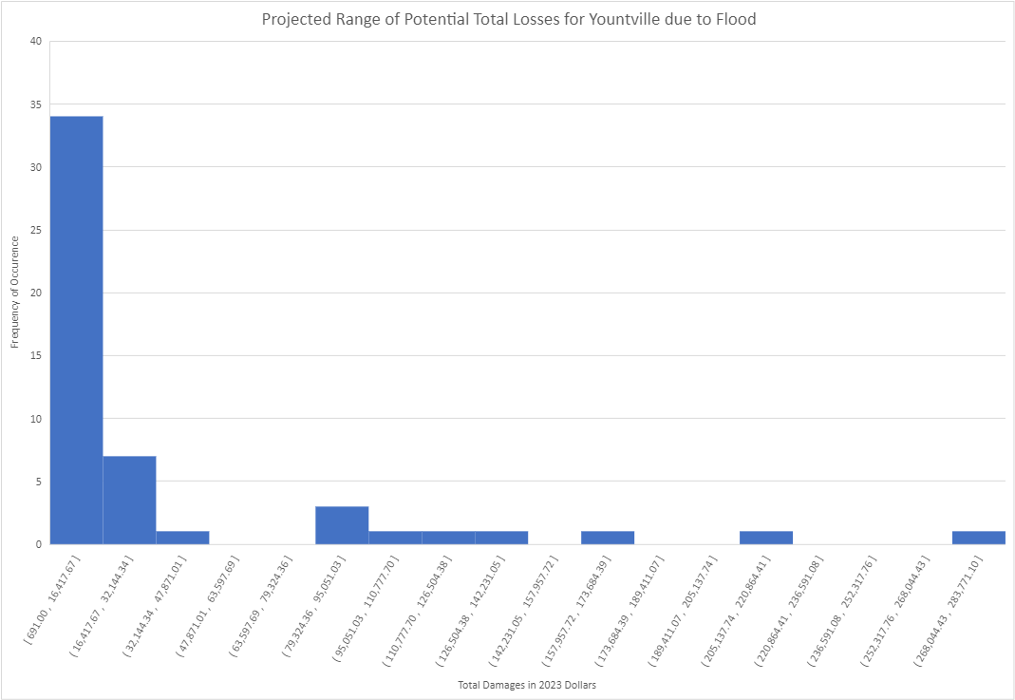

Table 4 – Summary Statistics for Projected Range of Total Losses if Similar Events Struck Yountville, CA
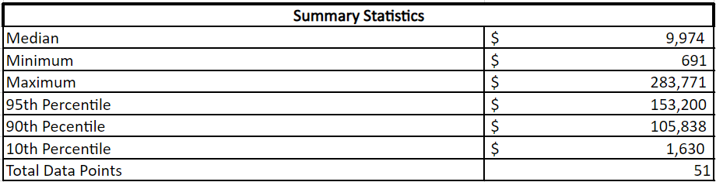
In sum, the totality of data depicted in this analysis allows Yountville to better understand its exposure to potential losses from flooding events. Further, the analysis provides a quantitative context for expectations regarding the impact of a flood on the Town. Tables 1, 2 and 3 each highlight critical elements that may better inform Yountville’s reserve strategy when considering risks posed by floods, including FEMA reimbursement per capita for floods and total losses to local governments after such events (both in 2023 dollars). Exhibit 3 visually summarizes the potential range of total damages if any of these historic flooding events were to strike the Town today. In conjunction with Table 4, the Town can use this information to get a snapshot of potential total losses for similar events moving forward and thus make more informed decisions as a local government. Finally, we should note that earlier in this report we cited First Street’s characterization of Yountville’s flood risk as “moderate.” First Street describes Napa County’s risk, on the whole, as “major.” This implies that Yountville’s risks are relatively less than other areas in Napa County, should a flood occur. This should influence how we interpret the results in Table 4.

Section 5- Detailed Analysis of Recession Risk
Like all local governments, the Town faces risk of revenue losses due to recession. The first step to understanding the Town’s vulnerability is to understand the composition of its revenue portfolio. Exhibit 1 shows the relative share of major revenue source in the General Fund.
It is no surprise to Town officials that the transient occupancy tax (TOT) is, by far, the most important revenue. This is important because TOT also has the reputation of being more vulnerable to economic recessions than other major revenue sources. For example, properties typically don’t decline in value much during a recession. Certainly, they did during the 2008 Great Recession, but that was unusual (though not unique). People also generally tend to keep up on property tax payments. Sales taxes have a reputation of being volatile, but even during a recession people make some purchases. TOT, especially when driven primarily by tourism, in theory, has further to fall because the money spent by tourists is completely discretionary.
Exhibit 1 – Composition of Town General Fund Revenues
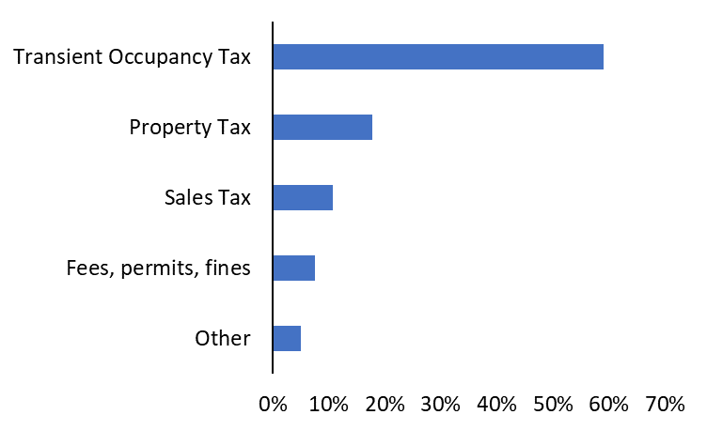

To get a better idea of how the risk of revenue losses might play out in Yountville, we examined historical data from Yountville, Napa, and other jurisdictions in the region. Yountville itself has changed quite a bit over the years. As we can see in Exhibit 2, total revenues have gone up almost 4-fold since 2008! This means that Yountville’s tax base is very different today than it was during the Great Recession, so the experience of the Great Recession may not be very informative of future risk.

Exhibit 2 – Town’s General Fund Revenues Since 2008
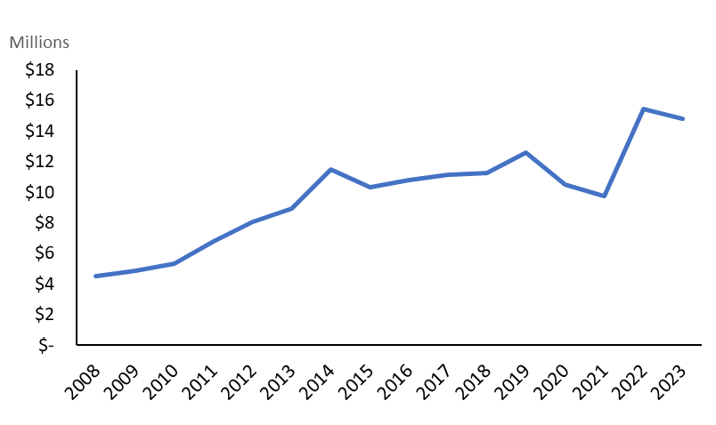

To get a better perspective, we looked at the experiences of other nearby jurisdictions. GFOA was able to obtain detailed information about the City of Napa’s experience.
We can start with TOT since that is the most important revenue for the Town. Exhibit 3 shows growth in the number of rooms across the entirety of Napa County and the City of Napa’s revenue per room (thus factoring out room growth). We see that the 2001 recession barely made a dent in the City’s TOT revenues. There was a more noticeable dip during the Great Recession, but the revenues then recovered to go on to new heights.
Exhibit 3 – Hotel Room Growth in Napa County and Relative City of Napa TOT Revenue per Hotel Room (1996 – 2013)

A look at Napa’s total TOT revenue tells a similar story. Exhibit 4 shows a very small decline in 2001 and a more noticeable decline in 2008, but not a catastrophic decline.
Exhibit 4 – Napa’s Annual TOT Revenue (FY 1996 – FY 2014)

We also gathered TOT data from Windsor, Larkspur, and Sausalito. Unfortunately, the data was not nearly as detailed as we obtained for Napa, but we can say that Windsor and Sausalito do not appear to have suffered a big decline and TOT revenues increased rapidly after 2008-09.
The conclusion we might draw from all of this is that tourism in the region appears not to suffer too much during recessions. While we should expect some decline, as the Napa experience shows, we might also expect a relatively quick recovery.
To gain a perspective on all the other general fund revenues, we can examine Napa’s experience. Exhibit 5 shows annual changes in all general fund revenue categories in the years around the Great Recession. This gives us a clue as to how long and how deep a decline might be for all the important revenue sources.

Exhibit 5 - City of Napa, CA Annual Change in General Fund Operating Revenues (FY 2006 - FY 2014)
 | FY 2007 | FY 2008 | FY 2009 | FY 2010 | FY 2011 | FY 2012 | FY 2013 | FY 2014*
Property Tax | 14.1% | 9.9% | -0.5% | -0.6% | -5.6% | 4.5% | 0.7% | 4.7%
Sales Tax | 13.6% | -1.4% | -1.6% | -13.0% | 5.5% | 6.8% | 9.6% | 6.2%
Transient Occupancy Tax (TOT) | 24.5% | 12.2% | -5.5% | 0.2% | 19.6% | 16.5% | 17.4% | 12.3%
Other Taxes, Business Licenses | -0.3% | 3.6% | -0.5% | -10.3% | 5.7% | 3.8% | 3.9% | 5.1%
Licenses & Permits | 45.0% | -13.0% | -28.7% | -30.8% | 8.1% | 36.0% | -17.1% | 12.5%
Interest & Rents | 125.6% | 78.0% | -31.8% | -71.5% | 20.2% | -17.4% | -54.1% | 76.2%
Intergovernmental | -52.4% | 81.1% | -50.8% | 34.9% | 14.3% | -38.0% | -1.8% | 28.4%
Charges for Service | 98.2% | -2.2% | -8.0% | -4.7% | -6.0% | 8.2% | 5.4% | 0.2%
Transfers/Other | 11.4% | 41.7% | -2.3% | -9.3% | -2.9% | 4.2% | 0.5% | 10.7%
Total | 18.3% | 9.0% | -5.0% | -6.7% | 1.9% | 6.8% | 5.4% | 7.2%
* Unaudited figures

We can sum up Napa’s losses in the important revenue categories as follows:
- Property taxes: 6% decline over 3 years.
- Sales taxes: 15% decline over 3 years.
- TOT: 5% decline over 2 years (the second year was flat, rather than decline).
- Charges for service: 18% decline over 2 years.
- Licenses and permits: 50% decline over 2 years.
- Other taxes, business licenses: 11% decline over 2 years.
If we took these same declines and applied them to the Town’s 2023 actual revenues, we would get a decline of $1.3 million or about 9% of total general fund revenues. This would probably represent a conservative approach because we are using the Great Recession as the historical analogue, which is the worst recession since World War 2. That said, it might also be argued that because Napa is a larger city with a more diversified tax base, it might be less vulnerable to recessions than Yountville. Hence, using the experience of the Great Recession might be less conservative than it first appears. Thus, a $1.3 million to $1.5 million reserve might represent a conservative approach for the Town. A recession like the 2001 dot.bomb recession was mild by historical standards. A smaller would be sufficient to cover that recession, with $1 million still representing a healthy amount.

Section 6 – Detailed Analysis of TOT Interruption Risk
The Town of Yountville’s General Fund relies primarily on transient occupancy tax (TOT). In the prior section, we discussed how recessions could impact the Town’s general fund revenues, including TOT. Economic recessions are not the only way TOT could be interrupted. To illustrate, COVID resulted in the largest decline in TOT that the Town and other municipalities in the region have experienced in decades. Natural catastrophes could interrupt TOT. Consider the following three scenarios:
- A strong earthquake damages hotel buildings, making them unoccupiable for a period.
- A wildfire causes a lot of smoke, dissuading tourists from visiting.
- A large flood (like from a dam failure) inundates hotel properties.
This section will consider risk of TOT interruptions from causes other than recessions or pandemics.
Between FY 2008 and FY 2023 the Town has received, on average, about ~$5.9 million per year from TOT. During that period TOT revenues recorded a strong average growth rate of 14% percent. In FY 2023 the Town received about $8.75 million from TOT. In comparison, Town only received $3.38 million in TOT revenue in FY 2008. Between 2008 and 2023, total TOT revenue has increased 469%. TOT is clearly the critical revenue for the Town. The Town’s reserve strategy should consider the risks for interruption to this revenue, outside of recessions.
To provide some insight into the potential of this risk, we looked at two sources of data. First was the historical patterns of TOT revenue, including those in other municipalities in the region. Second, is the location of the hotel properties in Yountville to see if they have relatively greater exposure to natural catastrophes than the rest of Yountville.
Let’s start with historical patterns. We looked at the following municipalities, in addition to the Town itself: Napa, Larkspur, Windsor, and Sausalito. Looking across these municipalities we see two consistent interruptions to TOT.
The first was COVID. The table below summarizes the trend in each municipality during Covid.
Municipality | 2020 Decline | 2021 Decline | 2022
Yountville | 25% | 15% | Beyond full recovery
Napa | 26% | 30% | Beyond full recovery
Larkspur | 32% | 41% | Partial recovery, full recovery in 2023
Windsor | 24% | 6% | Beyond full recovery
Sausalito* | 20% | 15% | Has not recovered
*Sausalito’s TOT appears to have entered downward trajectory well before 2020, so we should be careful about interpreting the failure of Sausalito’s TOT to recover to pre-COVID levels.

The second interruption was in 2017. Though this interruption was much smaller than COVID, there does seem to be a consistent downward movement in the trendline around this time. It is impossible for us to know for sure the cause of this dip, but it was consistent across the municipalities. There was a large wildfire in the region around that time, so it seems reasonable to conclude that this fire dissuaded some tourists for a period of one year.
The table below summarizes the temporary declines in each municipality during this one-year period.
Municipality | Year Over Year Decline
Yountville | 11%
Larkspur | 3%
Windsor | 9%
Napa did not experience a decline, but revenue growth did slow down. Sausalito entered a long-term decline right around this time, so it is hard to say how much was due to fires versus other factors.

Let’s now move on to the location of hotel properties in Yountville to see if they are at greater relative risk from natural catastrophes compared to other parts of Yountville.
First, we assume all properties are at the same risk of earthquake, meaning the magnitude of the earthquake will not be different in one part of Yountville versus another. That said, we have insufficient data on building construction to say if the hotels have building features that make them more resistant to earthquakes. Since many of the hotels are relatively new, they may have more modern building features. There may also be soil differences across Yountville that make some areas more prone to liquification than others. Unfortunately, we do not have access to data on soil conditions under the hotels versus other parts of Yountville.
That means we will focus our attention on wildfires and floods, where there is useful data available. First, we entered each hotel’s address into First Street’s Risk Factor, which gives flood and fire risk by address. We found that no hotels had greater relative risk than Yountville overall. The risk was the same as Yountville overall for wildfire and risk was less for flood risk for all hotels except for two properties. These two properties had the same risk as Yountville overall. On balance, the hotels appear to be at no more relative risk from fires or floods than Yountville overall and may even be at somewhat less risk of flooding. That said, there are areas of Yountville that are at less relative risk than Yountville overall for fire and flood. So, we should not get the impression that hotels face no danger – just that the danger to the hotels is not especially high relative to Yountville overall.
The First Street data set is very unlikely to include the risk of inundation from dam failure, so we examined that separately. We found the locations and addresses of each hotel within the Town’s borders. All hotels are concentrated to the east of the St. Helena highway, with several hotels located along Washington Street and two on Yount Street. See Exhibit 1 for detail.
Exhibit 1 – Map of Yountville Hotels
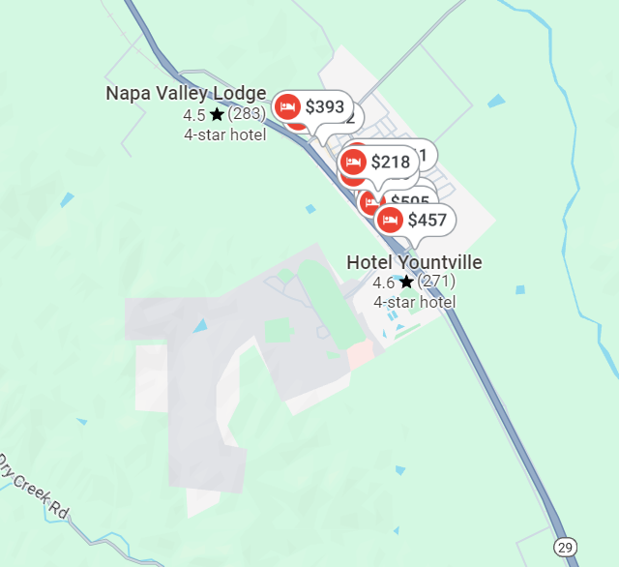
Second, we compared the locations of the Town’s hotels to the “Dam Inundation Areas” map, Exhibits 2.
Exhibit 2 – Yountville Dam Inundation Areas Map
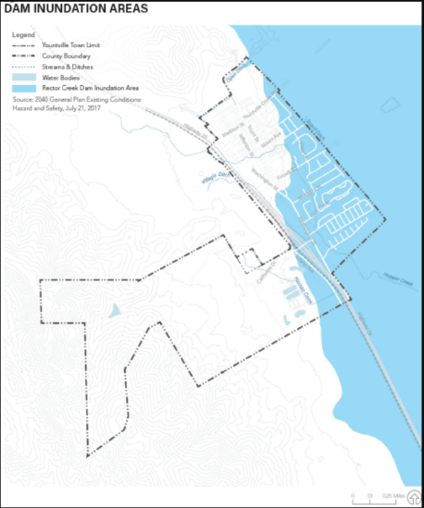
We see that if a dam failure occurred, the event would mostly affect the southeastern portion of the Town. When comparing the location of the Town’s hotels to the Dam Inundation Map, we see that some hotels may fall within the potential flooding zone. That said, we must remember that the County Hazard plan considers a dam failure to be “unlikely”.
In summary, the historical data shows that interruptions to TOT from events other than recessions are quite possible. In the case of COVID the losses were substantial. The 2017 losses were much less but were noticeable. The good news is that hotel properties in Yountville do not appear to be at more relative risk than the rest of Yountville from floods or wildfires.
For a reserve strategy, a less conservative approach might prepare for something on the scale of 2017 (an 11% decline). A more conservative approach would prepare for something larger. However, we should also remember that pandemics are analyzed as a separate risk, so we also don’t want to “double count” this risk. Hence, a more conservative approach might prepare something larger, but also combine preparation for an interruption from fire, flood, or earthquake with preparation for other more extraordinary sources of interruption, like a pandemic. In this case, the amount might be equal to the pandemic amount we describe later in this report, but in combination with that amount, not in addition to that amount.

Section 7 – Detailed Analysis of Cyberattack Risk
Local governments are at high risk for cyberattack, particularly ransomware attacks. In fact, studies have shown that local governments are one of the most popular ransomware targets for cybercriminals.
The Town currently has coverage under “Information Security & Privacy Insurance with Electronic Media Liability Coverage” along with a “Breach Response Endorsement.” GFOA is not an insurance analyst, and a comprehensive review of all policy details was outside the scope of our project, but we can offer the following observations from our review of the policy as it relates to the Town’s reserve strategy.
The insurance has a $2 million limit. There are also several sublimits for different kinds of coverages. For example, there is a $500,000 limit for “Business Interruption Loss Resulting from System Failure”. It is conceivable that a particularly bad attack could exceed one or more of these sublimits. Research suggests that the potential damages from and attack and size of the government are only weakly correlated. This means that small governments can be on the receiving end of large attacks. Losses over these sublimits might be covered using the Town’s reserves.
There is also a retention (deductible). The policy describes a sliding scale of retentions, depending on the insured’s size. The scale ranges from $50,000 to $250,000. Presumably, the Town would be on the lower end of this scale, however it is also very important to understand how retentions work in cyber policies. There are two basic approaches single retention and multiple retention. A cyber-attack could likely trigger multiple types of coverages within the policy. The Town’s policy appears to have around 20 different types of coverages. Each coverage has its own retention amount. Under single retention, the Town would pay the single highest retention across all the coverages triggered. Under multiple retention, each coverage’s retention would be handled separately. It is easy to imagine that if several coverages were triggered by an attack, the deductible amount the Town would be faced with could be multiple times larger under a multiple retention policy compared to a single retention policy. GFOA could not discern whether the policy is single or multiple retention from the documents provided. The Town may wish to inquire with their insurance provider on this point.
The policy provides coverage on a “claims made and reported basis”. According to the International Risk Management Institute (IRMI), a claims-made and reported policy is a type of policy in which a claim must be both made against the insured and reported to the insurer during the policy period for coverage to apply. Further, IRMI states: claims-made and reported policies are unfavorable from the insured's standpoint because it is sometimes difficult to report a claim to an insurer during a policy period if the claim is made late in that policy period. This is particularly important when it comes to cyber risk. For example, imagine malicious software infiltrated the Town’s network months ago but the Town finds out about it after the policy period is over. How would the policy cover that situation?
Cyberattacks can cause many types of losses. As mentioned above, the Town’s policy includes several types of coverages to address different losses. Nevertheless, cyber policies are rarely, if ever, comprehensive of every cost that could arise from every cyberattack scenario. Here are some examples of uncovered losses from the Town’s policy:
- The policy excludes acts-of-war but this is a common exclusion in insurance policies. Many ransomware attacks are thought to be perpetrated by state or quasi-state actors. If interpreted as an “act of war” the Town may not have coverage. In a related point, the policy does have $45 million aggregate limit for all members of the insurance pool the Town is part of. This might be relevant, for example, if a cyberattack does widespread damage across all members of the pool.
- The policy excludes property damage. For example, if a computer virus sabotages physical equipment besides computer hardware, the Town may not be covered. Many types of equipment, from vehicles to smart infrastructure, rely on computer systems. Sabotage of the computer system could result in physical damage to the asset.
- Betterment Coverage. This is coverage for expenses incurred to update, restore, or improve computer systems to a level beyond what existed before the attack. This might be important, for example, if the old system posed particular security vulnerabilities that could only be eliminated via a substantial upgrade in the system.

That said, GFOA is not suggesting the Town should have insurance coverage for all risks that could arise from a cyberattack. Such a policy might be cost prohibitive or even completely unobtainable. The Town, though, should be cognizant of what risks the Town is not commercially insuring because those risks are then being, de facto, self-insured.
Finally, municipal governments have found cyber policies to be increasingly expensive or hard to get at all in recent years. Insurance companies are becoming more rigorous in their underwriting practices and are increasingly requiring that policyholders have risk-mitigating practices in place, like multi-factor identification and more. This has two implications for the Town:
  - The Town should continue to stay up to date with nationally recognized cybersecurity standards.
  - The Town may need to be prepared to take on higher retentions for cyber policies in the future.
Given the points above, the Town might consider the following recommendations that have implication for the Town’s reserves:
- According to the Town’s IT Administrator, the Town stays up to date with nationally recognized cyber security recommendations. The Town also is diligent about running backups of internal servers, services, and files. First, this should help reduce the risk the Town faces from cyberattacks. Second, cybersecurity requirements do change as attackers evolve their methods. The Town should remain open to investing in additional cost-effective cyber controls to help mitigate future risks. This is because a dollar invested in prevention is usually going to be more effective than a dollar invested in remediation.
- Be prepared to retain more risk on a cyber insurance policy. If policies were to become substantially more expensive (or, worst case, unavailable), the Town could lower the cost by retaining more risk. This could be accounted for in Town’s reserve amount. As we stated above, it is conceivable that a cyberattack could cost the Town more than the sublimits outlined in the policy. Therefore, “retention” of risk is not just the insurance deductible, but also includes the risk of a catastrophic attack that costs more than the policy limit or that causes damages that are not covered under the policy.
Because the costs of cyber risk are variable it is hard to estimate an amount to hold for a reserve with the available data. The Town’s current policy does cover many kinds of cyber risks. The Town’s “retained” risks appear to be:
- The deductible costs, especially if the Town is responsible for covering multiple deductibles.
- Damages in excess of the sublimits under any of the individual coverages.
- Uncovered risks, which should be remote relative to the risks that are covered.
GFOA has observed that $1 million is a common limit on cyber policies. Given that most risks are covered, a conservative approach might take $1 million as a starting point and reserve some fraction of that for retained risks, which will place at $250,000 for discussion purposes. A less conservative approach would be to rely exclusively on the Town’s commercial insurance and its strong preventative posture and not hold additional reserves for cyber risk.

Section 8 – Detailed Analysis of Pandemics / Infectious Disease Risk
COVID-19 has made people more aware of the risks posed by pandemics. First, let’s consider the historical frequency of pandemics that have had a substantial impact on the United States: the 1918 flu and the COVID-19 pandemic. This suggests pandemics might occur once every 100 years in the United States. However, one could argue that pandemics will be more likely in the future. For example, easier travel means that infectious diseases could spread more easily. Global climate change could create environments that are more hospitable to disease carrying organisms. This means that the Town should probably be more cognizant of pandemic risk than historical frequency might suggest.
There are two types of financial losses the Town could incur from a pandemic: increased costs and decreased revenues.
We used the Town’s actual experience from COVID-19 to provide insight into increased costs. The Town’s actual additional annual expenditures were less than $50,000. This is not much compared to the figures we are considering for other risks the Town is subject to. The Town does not have the same public health responsibilities as Napa County, for example, so it is understandable that costs may not be high.
As for revenues, the potential losses are much larger. If we look at the Town’s $12.6 million in general fund revenue in 2019 and compare it to 2020 actual revenues of $10.5 million, we see that the Town has just over $2 million less in revenues in 2020 compared to 2019. Revenues continued to decline in 2021 – general fund revenues were $9.7 million. Comparing the 2019 revenues of $12.6 million to $9.7 million yields a gap of almost $3 million. If we add that to the $2 million decline from 2019 to 2020, we arrive at about a $5 million total gap between actual annual revenue and what we might have expected the General Fund to take in, during those two years, under a conservative estimate. Most of the general fund decline is attributable to TOT since that is the Town’s largest revenue.
Pandemics are an extraordinary type of extreme event! Therefore, we must consider the potential for extraordinary support from state or federal government.
For expenditures, it is reasonable to assume FEMA reimbursement for costs at the customary level of 75%. In fact, the Town is still pursuing reimbursement for some of its COVID costs, which illustrates that federal assistance is not a substitute for reserves, but is a way to replenish them.
Coverage of lost revenue is not as clear cut. First, we must consider if there will be any revenue coverage at all. The experience of the COVID-19 pandemic suggested that Democratic officials were more favorably disposed towards such federal financial assistance for local governments than Republican officials. Since we have a two-party system, we might there is an equal chance (50/50) one or the other will be in power and thus a 50/50 chance that federal officials will provide support. Assuming there is financial support, the next question is: how much will there be? The Town’s received $50,000 from CARES and just over $700,000 from ARPA. Though certainly this assistance was helpful, it does illustrate that such assistance can’t be expected to completely replace the Town’s losses.
In summary, pandemics can have a large impact on both revenue and expenditures for the Town. Further, it may behoove the Town to consider pandemics a more salient risk than pure historical experience would suggest. This is because of our more interconnected world and because of changes in the environment that might make pandemics more likely to occur and spread. Though intergovernmental support may be available and available in large amounts when a pandemic occurs, there is not a well-established precedent like there is for FEMA support of natural catastrophes like earthquakes, wildfires, floods, etc. Financial support similar to that received for COVID-19 seems far from guaranteed, so the Town should consider how its reserve could help buffer against a pandemic. The historical losses from COVID-19 would be reasonable analogue for a future pandemic.

The 6.8 was in Washington State in 2001. We used this because it was a larger magnitude quake that those in California for which data was available.
To represent the “average” we are using the median, which means 50% observations fall on one side of the median and 50% fall on the other. The median is often considered a better indicator of the “center” of a data set when data sets include extreme values, as in the case with financial losses from extreme events.
The website notes that this is true as of when that section of the site was written. According to a May 2022 story in the Napa Valley Register, “Rector Dam northeast of Yountville received a "satisfactory" rating — the best possible — on an Associated Press list of dam conditions”.
GFOA statistical test that showed only a 5% chance of observing this pattern by chance. In other words, it is highly unlikely this pattern is the result of just “dumb luck” in the data.
The largest losses to a small municipality were experienced by St. Helena, which was over $1.1 million when scaled to present day Yountville. That said, according the First Street Foundation, St. Helena is at “major” risk from wildfire, while Yountville is “moderate”. This implies that Yountville would be less likely to experience a similar loss to St. Helena’s.
To get risk estimates for any community, visit: https://firststreet.org/risk-factor/
GFOA statistical test that showed only a 10% chance of observing this pattern by chance. In other words, it is unlikely this pattern is the result of just “dumb luck” in the data.
Though COVID, technically, induced a recession, it is not a good representation of a classic economic recession.
GFOA emailed several municipalities in the region to ask for historical TOT data. These four replied.
We believe this is a conservative estimate because revenues are higher today than in 2019, which suggests the Town’s revenues were on an upward trend in 2019, before being interrupted by COVID.
The low amount puts pandemics at $1 million and TOT interruption at $1 million. It puts the high of both these risks together at $3 million. The high total also uses the largest number in the flood row.
https://www.countyofnapa.org/DocumentCenter/View/20613/EOP-Napa-County_Dec-2020
https://earthquake.usgs.gov/earthquakes/map/?extent=37.66752,-123.35724&extent=38.63618,-121.15997&range=search&timeZone=utc&search=%7B%22name%22:%22Search%20Results%22,%22params%22:%7B%22starttime%22:%221972-12-31%2000:00:00%22,%22endtime%22:%222022-12-31%2023:59:59%22,%22maxlatitude%22:38.691,%22minlatitude%22:37.449,%22maxlongitude%22:-120.729,%22minlongitude%22:-123.552,%22minmagnitude%22:4.5,%22orderby%22:%22time%22%7D%7D
“caused damage, death, and injuries” https://www.countyofnapa.org/DocumentCenter/View/20613/EOP-Napa-County_Dec-2020.
https://earthquake.usgs.gov/earthquakes/map/?extent=37.09681,-124.33777&extent=39.03625,-119.94324&range=search&timeZone=utc&search=%7B%22name%22:%22Search%20Results%22,%22params%22:%7B%22starttime%22:%221972-12-31%2000:00:00%22,%22endtime%22:%222022-12-31%2023:59:59%22,%22maxlatitude%22:38.691,%22minlatitude%22:37.449,%22maxlongitude%22:-120.729,%22minlongitude%22:-123.552,%22minmagnitude%22:2.5,%22orderby%22:%22time%22%7D%7D
https://www.usgs.gov/media/images/graph-showing-earthquake-magnitudes-and-equivalent-energy-release
https://www.earthquakeauthority.com/California-Earthquake-Risk/Faults-By-County
https://www.archives.gov/legislative/features/sf
https://www.usgs.gov/media/images/graph-showing-earthquake-magnitudes-and-equivalent-energy-release
https://www.countyofnapa.org/DocumentCenter/View/20613/EOP-Napa-County_Dec-2020
https://www.usgs.gov/media/images/graph-showing-earthquake-magnitudes-and-equivalent-energy-release
https://www2.census.gov/census_2000/datasets/demographic_profile/Washington/2kh53.pdf
https://dof.ca.gov/forecasting/demographics/estimates/
https://www.epa.gov/climate-indicators/climate-change-indicators-wildfires
https://www.countyofnapa.org/DocumentCenter/View/20613/EOP-Napa-County_Dec-2020
https://projects.capradio.org/california-fire-history/#9.17/38.4166/-122.5854
https://projects.capradio.org/california-fire-history/#11.17/38.4057/-122.3758
https://projects.capradio.org/california-fire-history/#8.17/38.085/-122.517
https://projects.capradio.org/california-fire-history/#11.17/38.4057/-122.3758
https://www.countyofnapa.org/DocumentCenter/View/20613/EOP-Napa-County_Dec-2020
https://www.jpl.nasa.gov/edu/news/2016/8/22/back-to-school-burn-the-science-of-wildfires/
https://www.fws.gov/story/2022-10/how-does-wildfire-impact-wildlife-and-forests
https://www.wfirescience.org/sites/default/files/publications/Fire%20Severity.pdf.
https://osfm.fire.ca.gov/media/h5sne0ia/fhsz_county_sra_11x17_2022_napa_2.pdf
https://osfm.fire.ca.gov/media/mfvb2mjf/2022-fhsz-faqs-july-2022.pdf
https://riskfactor.com/city/yountville/686930_fsid/fire
https://www.countyofnapa.org/DocumentCenter/View/20613/EOP-Napa-County_Dec-2020
https://www.epa.gov/climate-indicators/climate-change-indicators-wildfires
https://www.noaa.gov/noaa-wildfire/wildfire-climate-connection
https://www.epa.gov/climate-indicators/climate-change-indicators-wildfires
https://www.countyofnapa.org/DocumentCenter/View/20613/EOP-Napa-County_Dec-2020
https://riskfactor.com/city/yountville/686930_fsid/flood
https://www.countyofnapa.org/DocumentCenter/View/20613/EOP-Napa-County_Dec-2020
https://water.ca.gov/News/News-Releases/2022/Dec-22/Changing-Climate-Shift-to-More-Extreme-Weather-Intensify-Risk-of-Flooding-in-California
https://riskfactor.com/city/yountville/686930_fsid/flood
The data we were able to get started in 2008-09 so we do not have a full picture of the Great Recession for Windsor and Sausalito. However, based on the Napa data, it appears the bulk of the decline for Napa happened after 2007/08. Hence, it seems reasonable to conclude that Windsor and Sausalito did not suffer a catastrophic decline in TOT during the Great Recession because we observed revenue increases at the same time that Napa’s revenue was flat. Larkspur’s data did not go far enough back to provide insight into what happened during the Great Recession.
GFOA emailed several municipalities in the region to ask for historical TOT data. These four replied.
The GFOA report “Cyber Risk Savvy” describes multiple such sources. It is available at gfoa.org.
Retentions and deductibles not quite synonyms, but they are close. Retentions can include any source of loss not commercially insured – it is the risk retained by the holder of the policy. In the part of the policy this paragraph refers to, “retentions” are being used in a way that most people understand insurance deductibles.
Acts of war might be addressed in the original policy that the endorsement modifies.
We did not think it was appropriate to account for disease outbreaks that did not impact the US as that would overstate the frequency of events that could impact Yountville. An example is the 2012 Middle East respiratory syndrome coronavirus.
We believe this is a conservative estimate because revenues are higher today than in 2019, which suggests the Town’s revenues were on an upward trend in 2019, before being interrupted by COVID.

